Programming Assignment 2:

Sorting Social Security Numbers

Yuxiao (Tom) Zheng

CS146-Section7

1. Unzip and Installation (P.1-5)

2. Programming Design(P.6-14)

3. Implementation(P.15-19)

4. classes/subroutines/bucketSort radixSort explanation (P.20-31)

5. Self-testing (P.32-35)

6. Problems encountered during implementation(P.36-39)

7. Leasson Learned(P. 40)

8. Running Time Big- $Ο$ (Junit -Test)

(P. 41-46)

1. unzip and install

* Unzip the zip folder, there are three part, a SRC folder that contains all of the .java files,

Quick_SSN.txt, Radix_SSN.txt, Bucket_SSN.txt, Random_SSN.txt, home.png, android.png, transfer.txt, Junit.txt, and a TEST folder contains Junit test .java files: bucketTest.java, quickTest.java, and radixTest.java

a Programing Report which is Microsoft Word Document which you are reading it now

and a runnable .jar file named “GoogleSortingSSN.jar”.

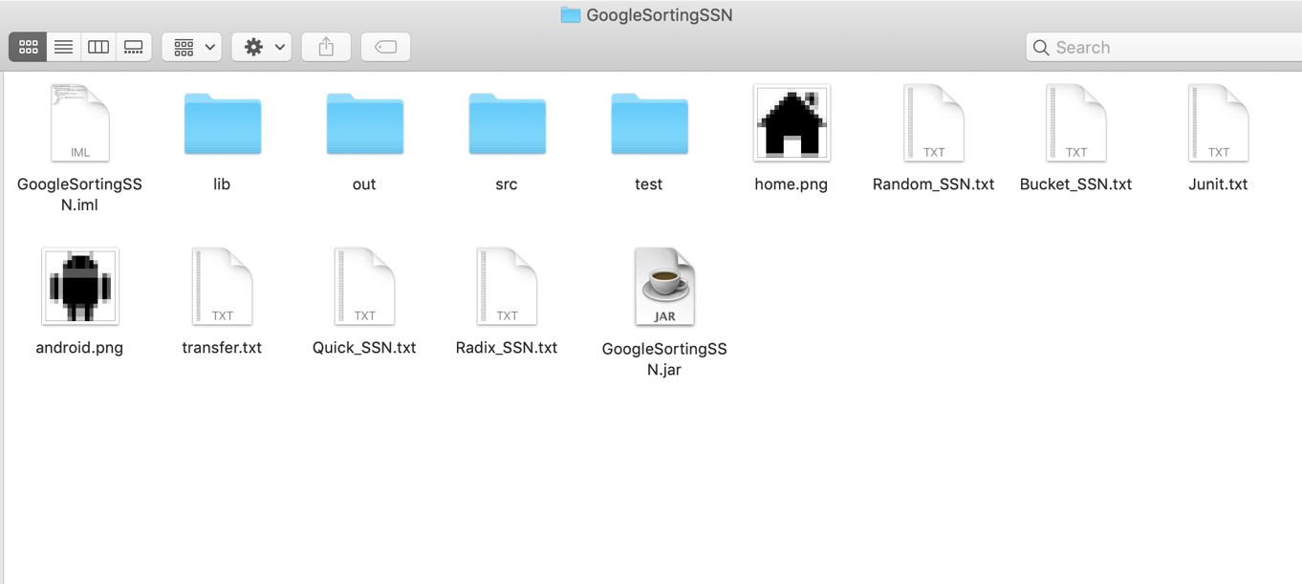

* Now the above are the all of required files including icon .png
* Still need to import jdk 8, because we using javaFX lirbary

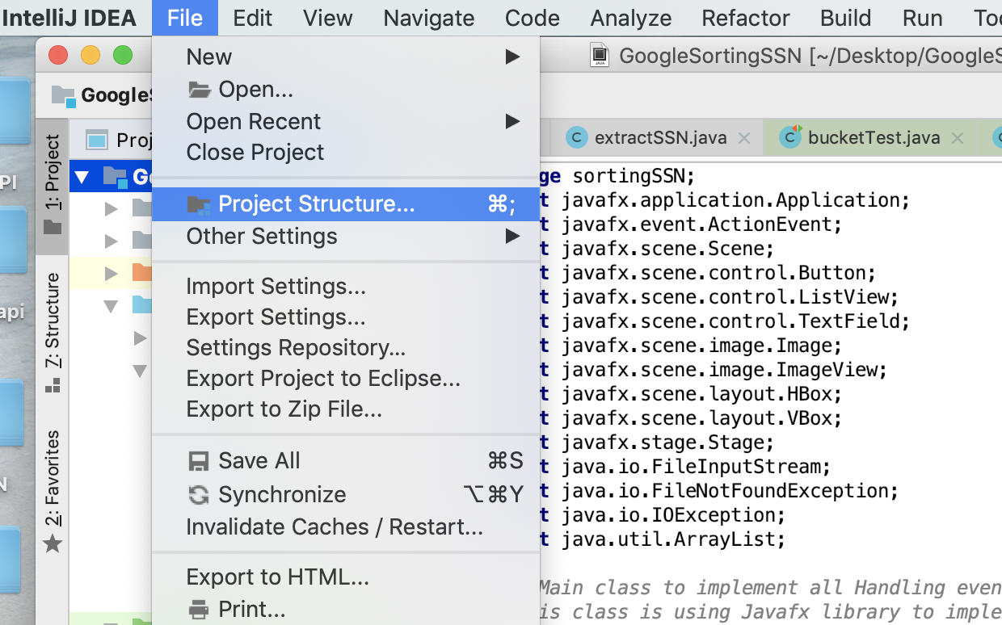

1. Click File $→$ Project Structure
2. Choose SDKs $→$ click “+”
3. Pick the jdk 8 to import

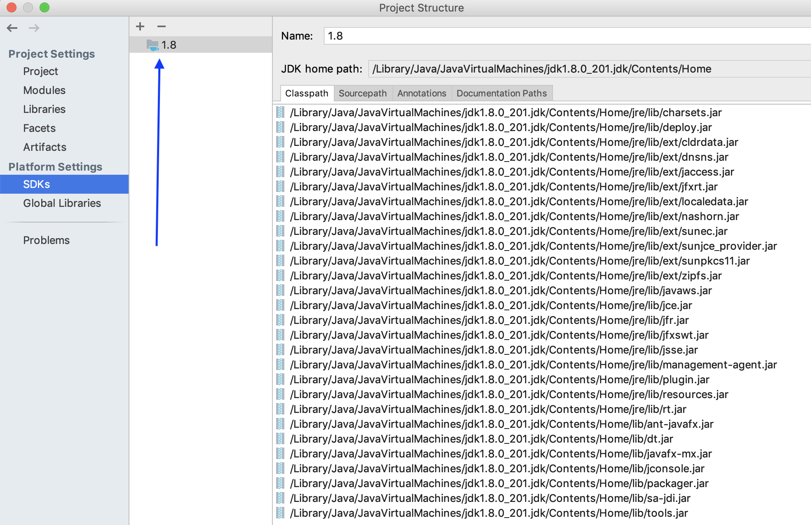

* Now, the whole program interface look like the following:

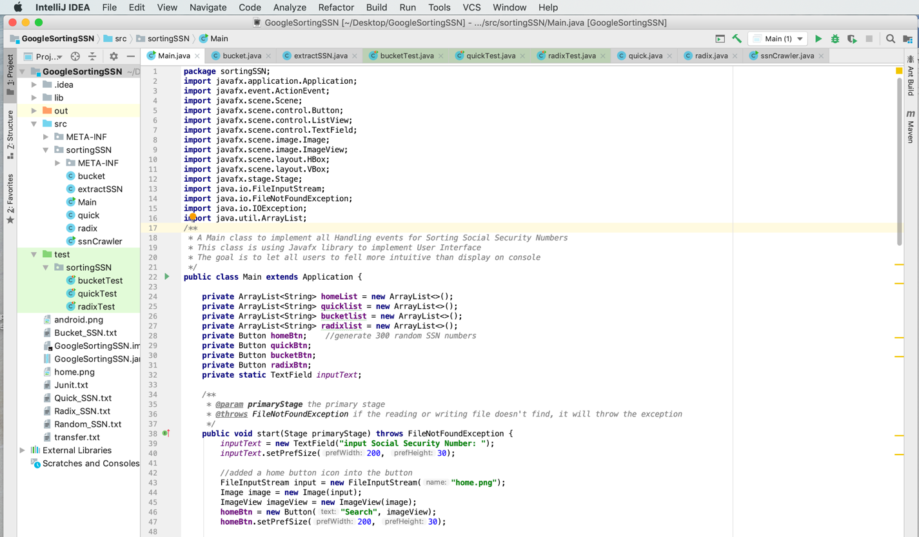

* If you have seen this program main interface, that means you have installed successfully!

Now you can test all function and Junit test!

* Note: the left directory path should look like the following:

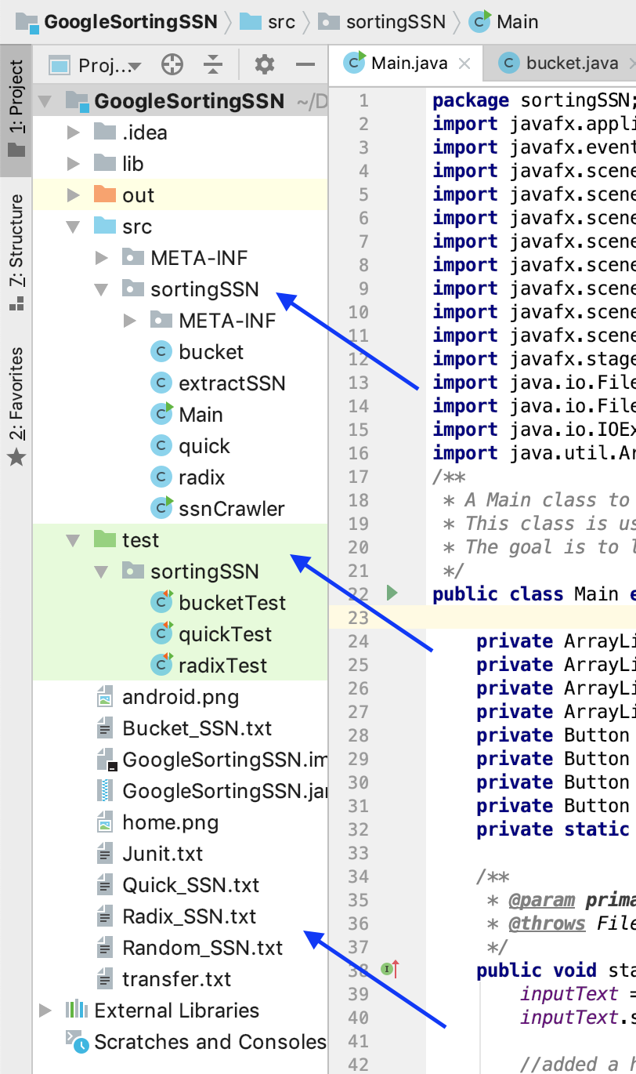

* Warning: Don’t move the .txt file and .png file to the other folder, or you won’t see the icon display on the button in the User Interface, or you won’t see the SSN numbers into the .txt files.
* Note: the further installation for Junit Test, you will see it in Part 8 :

Running Time Big- $Ο$ (Junit -Test)

2. Programming Design (deeply encapsulation)

* UML diagram:

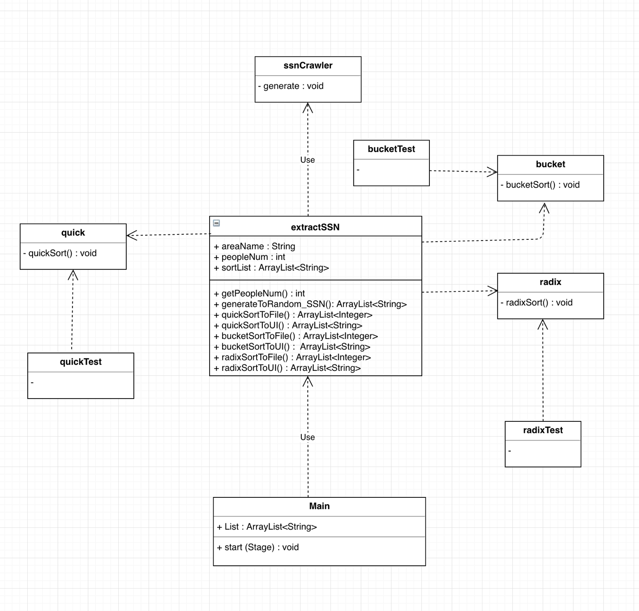

* Create a ssnCrawler class which has a method named [void generate()], this method will generate 300 random SSN numbers.
* Create a class extractSSN which has some necessary attributes:

*/* Area name */*

private String necs = "[Northeast Coast States] : ";

private String scs = "[South Coast States] : ";

private String ms = "[Middle States] : ";

private String ms = "[Middle States] : ";  
private String nwcs = "[Northwest Coast States] : ";  
private String wcs = "[West Coast States] : ";  
*/* Area people number */*public static int *necsPeople*;  
public static int *scsPeople*;  
public static int *msPeople*;  
public static int *nwcsPeople*;  
public static int *wcsPeople*;  
*/* after quickSort, bucketSort, and radixSort, all sorted data will into the required ArrayList */*private ArrayList<String> strlist = new ArrayList<>();  
private ArrayList<String> quickList = new ArrayList<>();  
private ArrayList<String> bucketList = new ArrayList<>();  
private ArrayList<String> radixList = new ArrayList<>();  
*/* Access Method: get different area people's number */*public int getNecsPeople(){  
 return *necsPeople*;  
}  
public int getScsPeople(){  
 return *scsPeople*;  
}  
public int getMsPeople(){  
 return *msPeople*;  
}  
public int getNwcsPeople(){  
 return *nwcsPeople*;  
}  
public int getWcsPeople(){  
 return *wcsPeople*;  
}

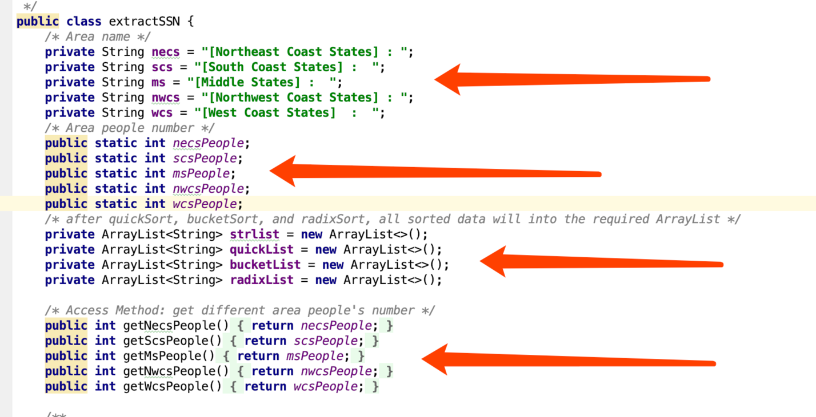

The above 4 parts:

1. displaying the area name on the User Interface
2. will count the total numbers of different area’s people
3. provides a data structure ArrayList, which can store 300 sorted SSN numbers into my arrayList
4. return the changed people number of different area

* Inside extractSSN class, I will create seven method to help implement different functioning:

1. public ArrayList<String> generateToRandom_SSN()

2. public ArrayList<Integer> quickSortToFile()

3. public ArrayList<String> quickSortToUI()

4. public ArrayList<Integer> bucketSortToFile()

5. public ArrayList<String> bucketSortToUI()

6. public ArrayList<Integer> radixSortToFile()

7. public ArrayList<String> radixSortToUI()

Originally, this seven methods’codes will write into the Main class; they help Main class implement different functioning.

Now, from method() 1 to 7, I only write either one sentence or two sentences inside try() clase of different button event in the Main class to implement the user’s desired functioning : this way offers the highest possible degeree of encapsulation; see the codes of 7 methods encapsulating in extractSSN class. I will further explain in Part 4,

“4. Classes/Subrountines/function call”.

* Create a class quick which provide a method called quickSort() to help sort 300 SSN numbers

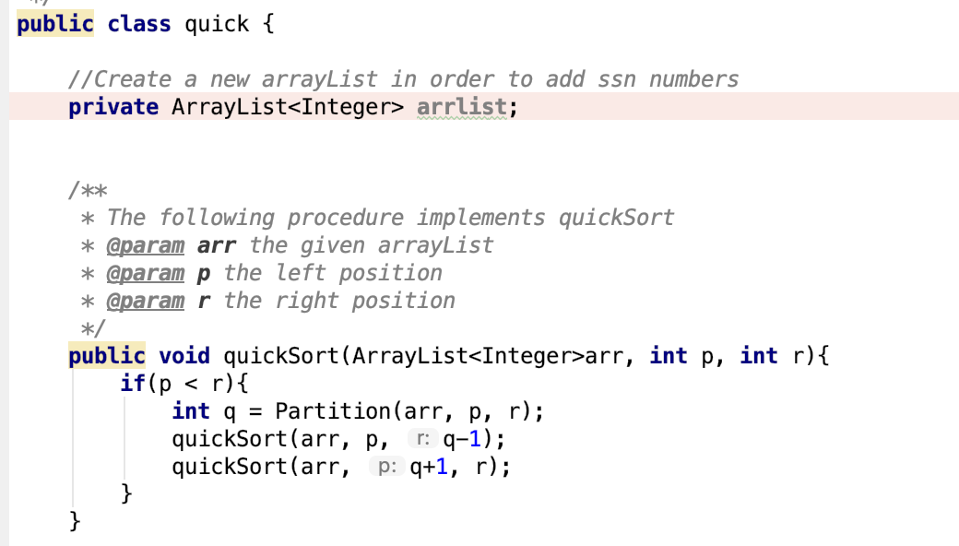

* Create a class bucket which provide a method called bucketSort() to help sort 300 SSN numbers

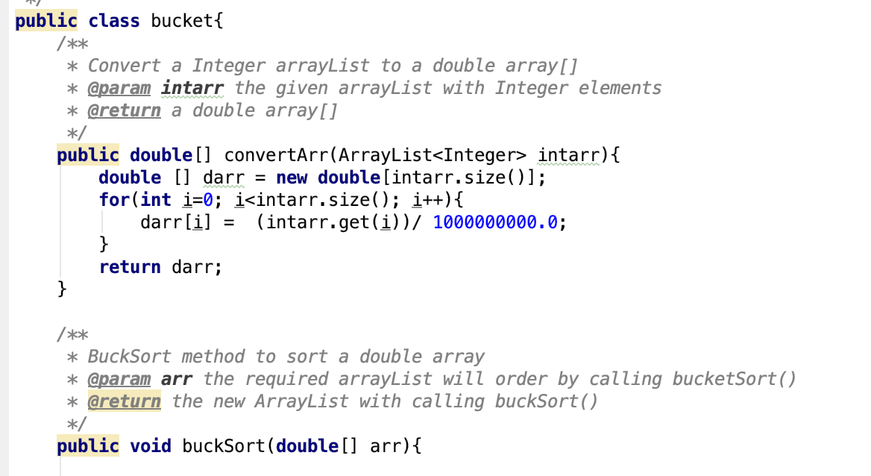

* Create a class radix which provide a method called raidxSort() to help sort 300 SSN numbers

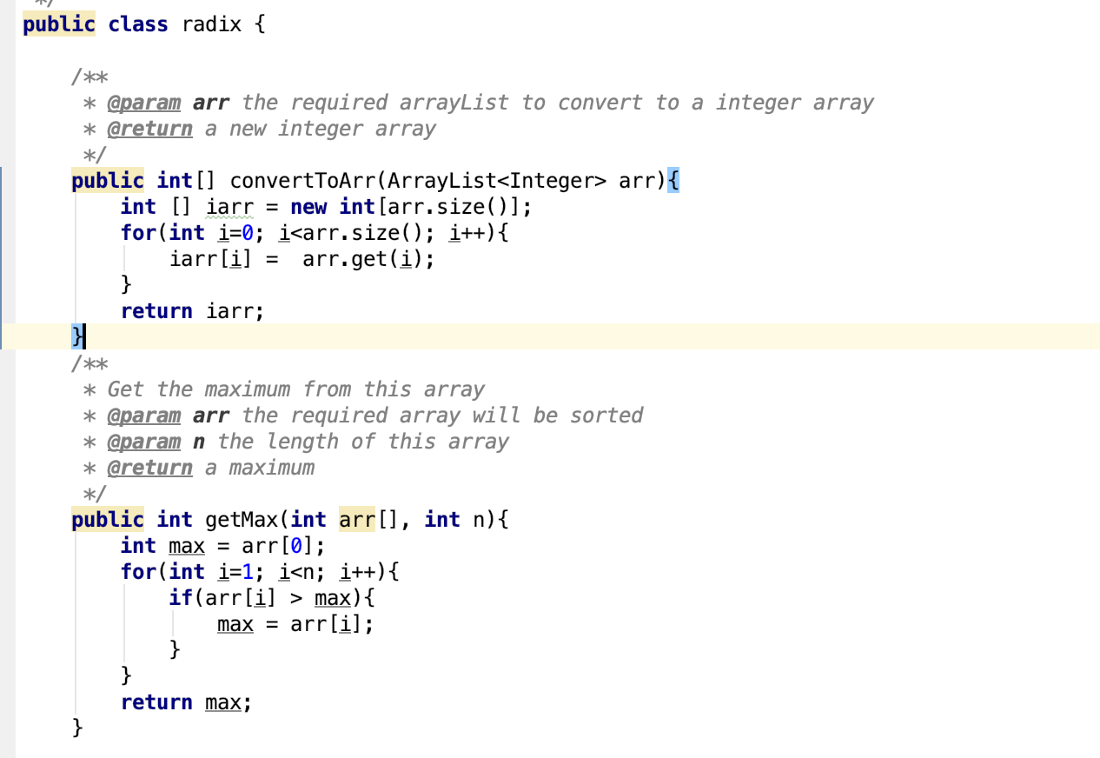

* Create a Main class with 4 arrayLists and 4 Buttons :

private ArrayList<String> homeList = new ArrayList<>();  
private ArrayList<String> quicklist = new ArrayList<>();  
private ArrayList<String> bucketlist = new ArrayList<>();  
private ArrayList<String> radixlist = new ArrayList<>();  
private Button homeBtn; *//generate 300 random SSN numbers*private Button quickBtn;  
private Button bucketBtn;  
private Button radixBtn;

* Every button will add a .png file on the button, then the User Interface will show a button with the image (icon) :

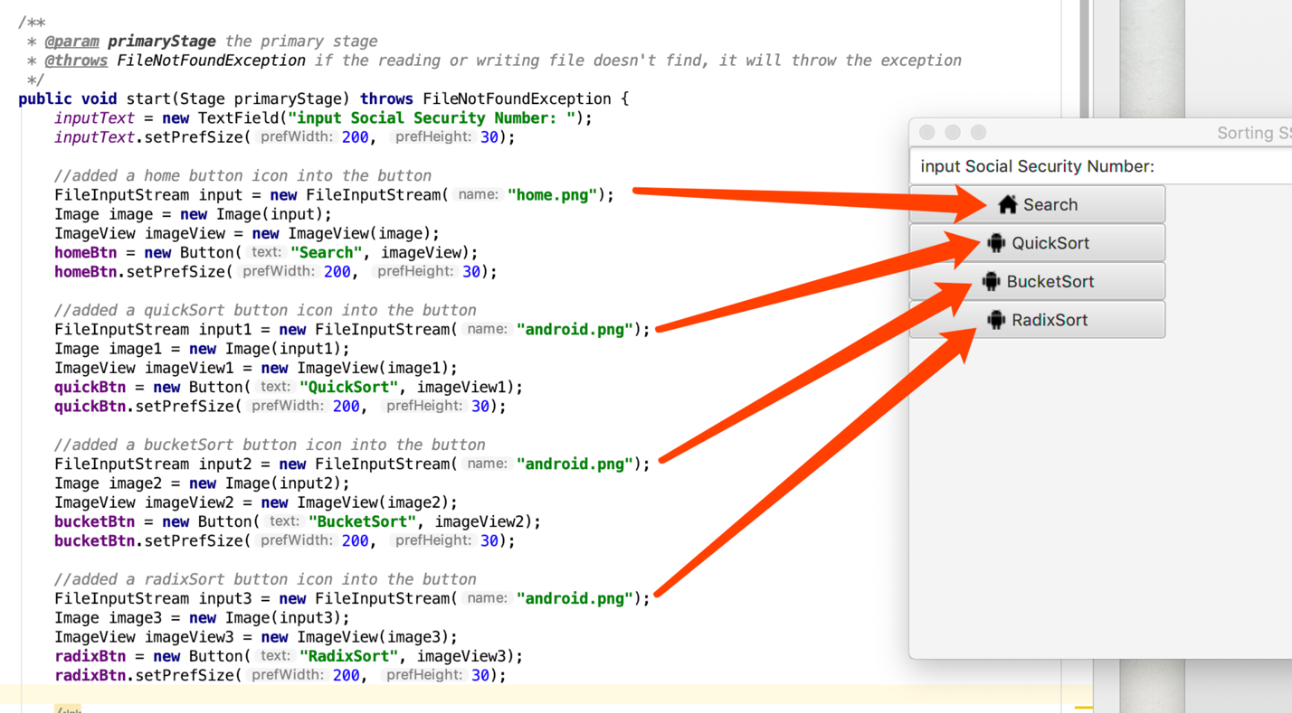

* Inside Main class, there are 4 arrayList<String> to hold the sorted SSN numbers, this step’s purpose is to one by one call the ListView<String> to add every record, finally all record will dispay on the User Interface:

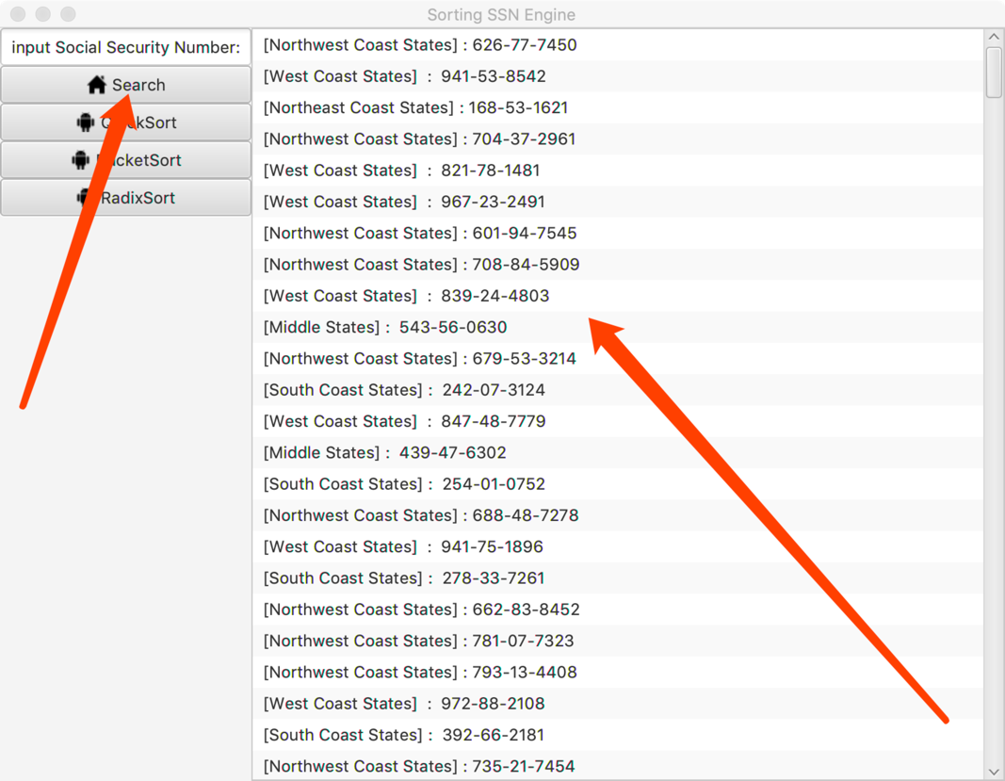

* In the Main class, there are 4 button event that will implment different functioning;
* A primary method start(Stage ..) to execute the main task.

public void start(Stage primaryStage) throws FileNotFoundException { … }

* four different button to implement different desired functioning:

homeBtn.setOnAction((ActionEvent event)-> { … }

homeBtn will generate the Radom 300 SSN into the Random_SSN.txt

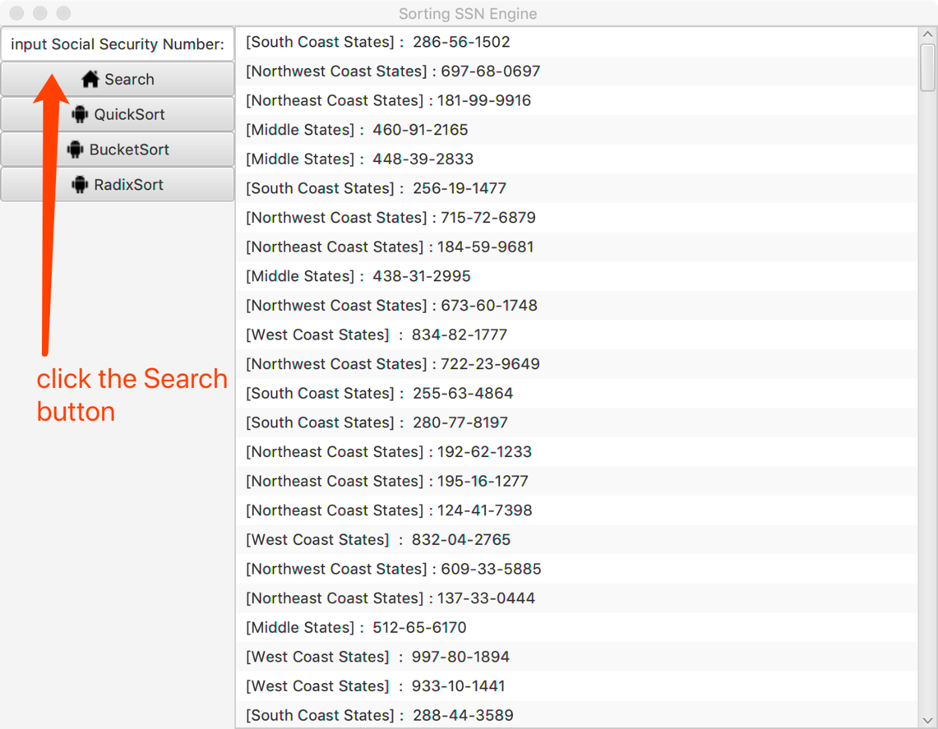

quickBtn.setOnAction((ActionEvent event)->{ … }

quickBtn will display the 300 SSN on the User Interface, and it will write 300 SSN into the Quick_SSN.txt

bucketBtn.setOnAction((ActionEvent event)->{ … }

bucketBtn will display the 300 SSN on the User Interface, and it will write 300 SSN into the Quick_SSN.txt

radixBtn.setOnAction((ActionEvent event)->{ … }

radixBtn will display the 300 SSN on the User Interface, and it will write 300 SSN into the Radix_SSN.txt

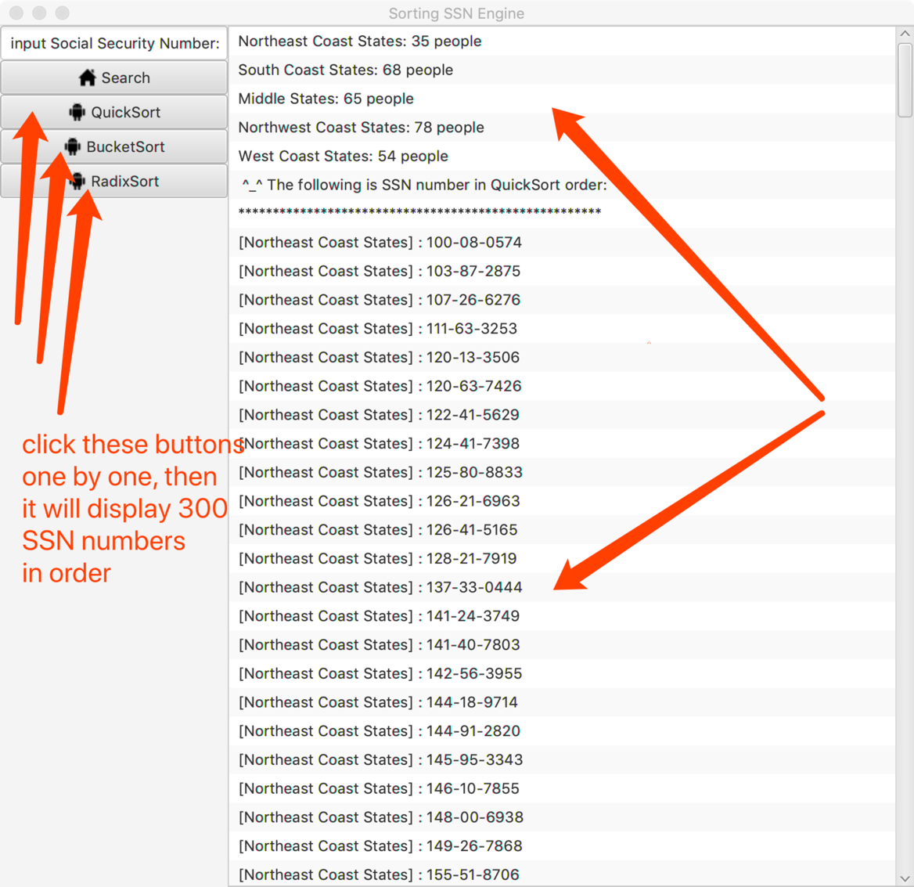

* The following shows that these button event can also write all SSN data into the required .txt files.

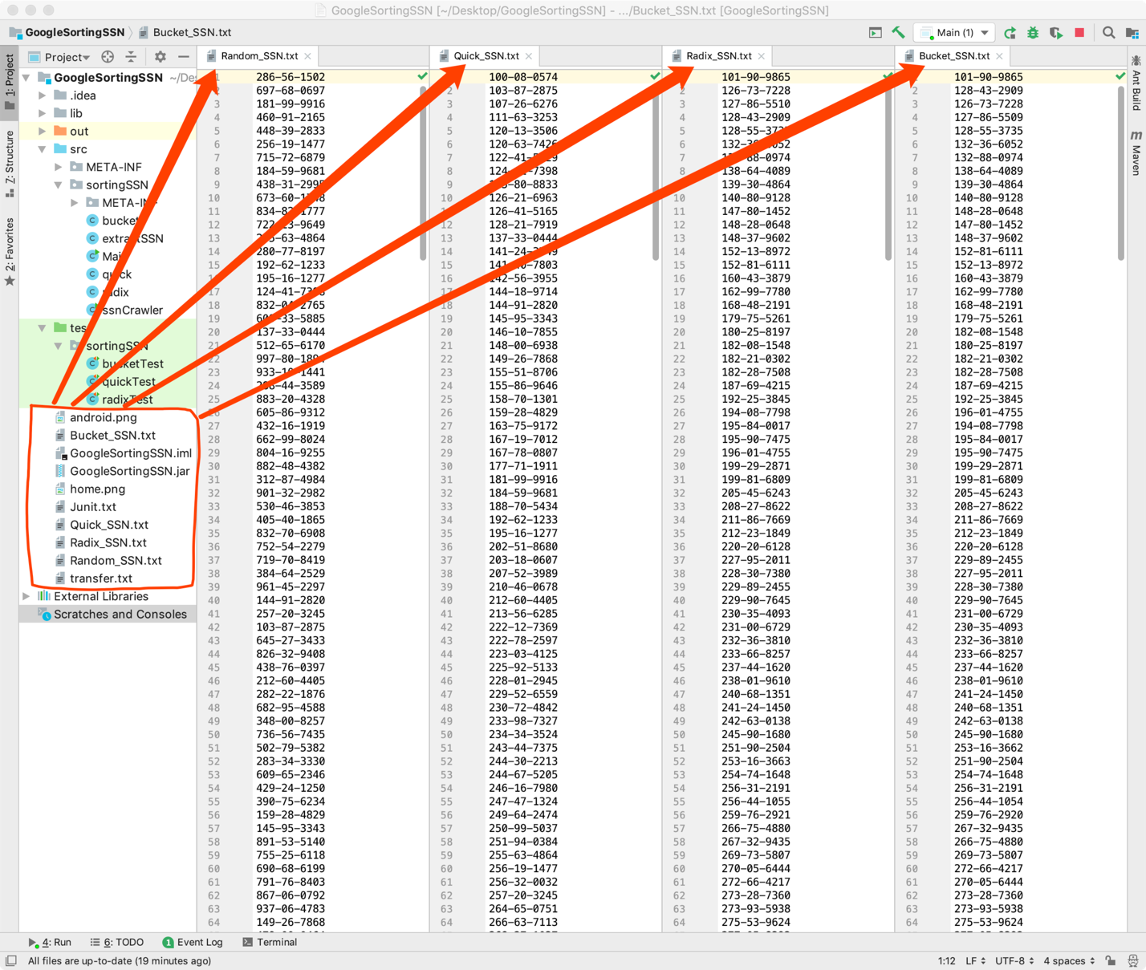

3. Implementation

ssnCrawler class has a method void generate() , which generate 300 SSN numbers.

int randomSSN = 100000000 + new Random().nextInt(900000000);

this statement will generate a 9-place number, from 0 ~ 999-99-9999, Note: it will not generate with “000” at the beginning.

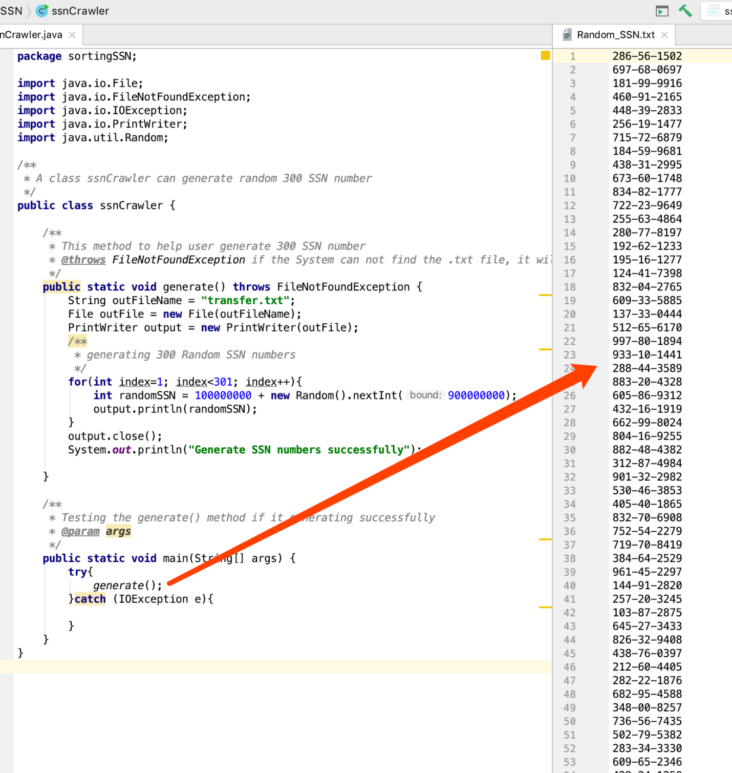

Implement extractSSN class’s functioning:

**1. public** ArrayList<String> generateToRandom_SSN()

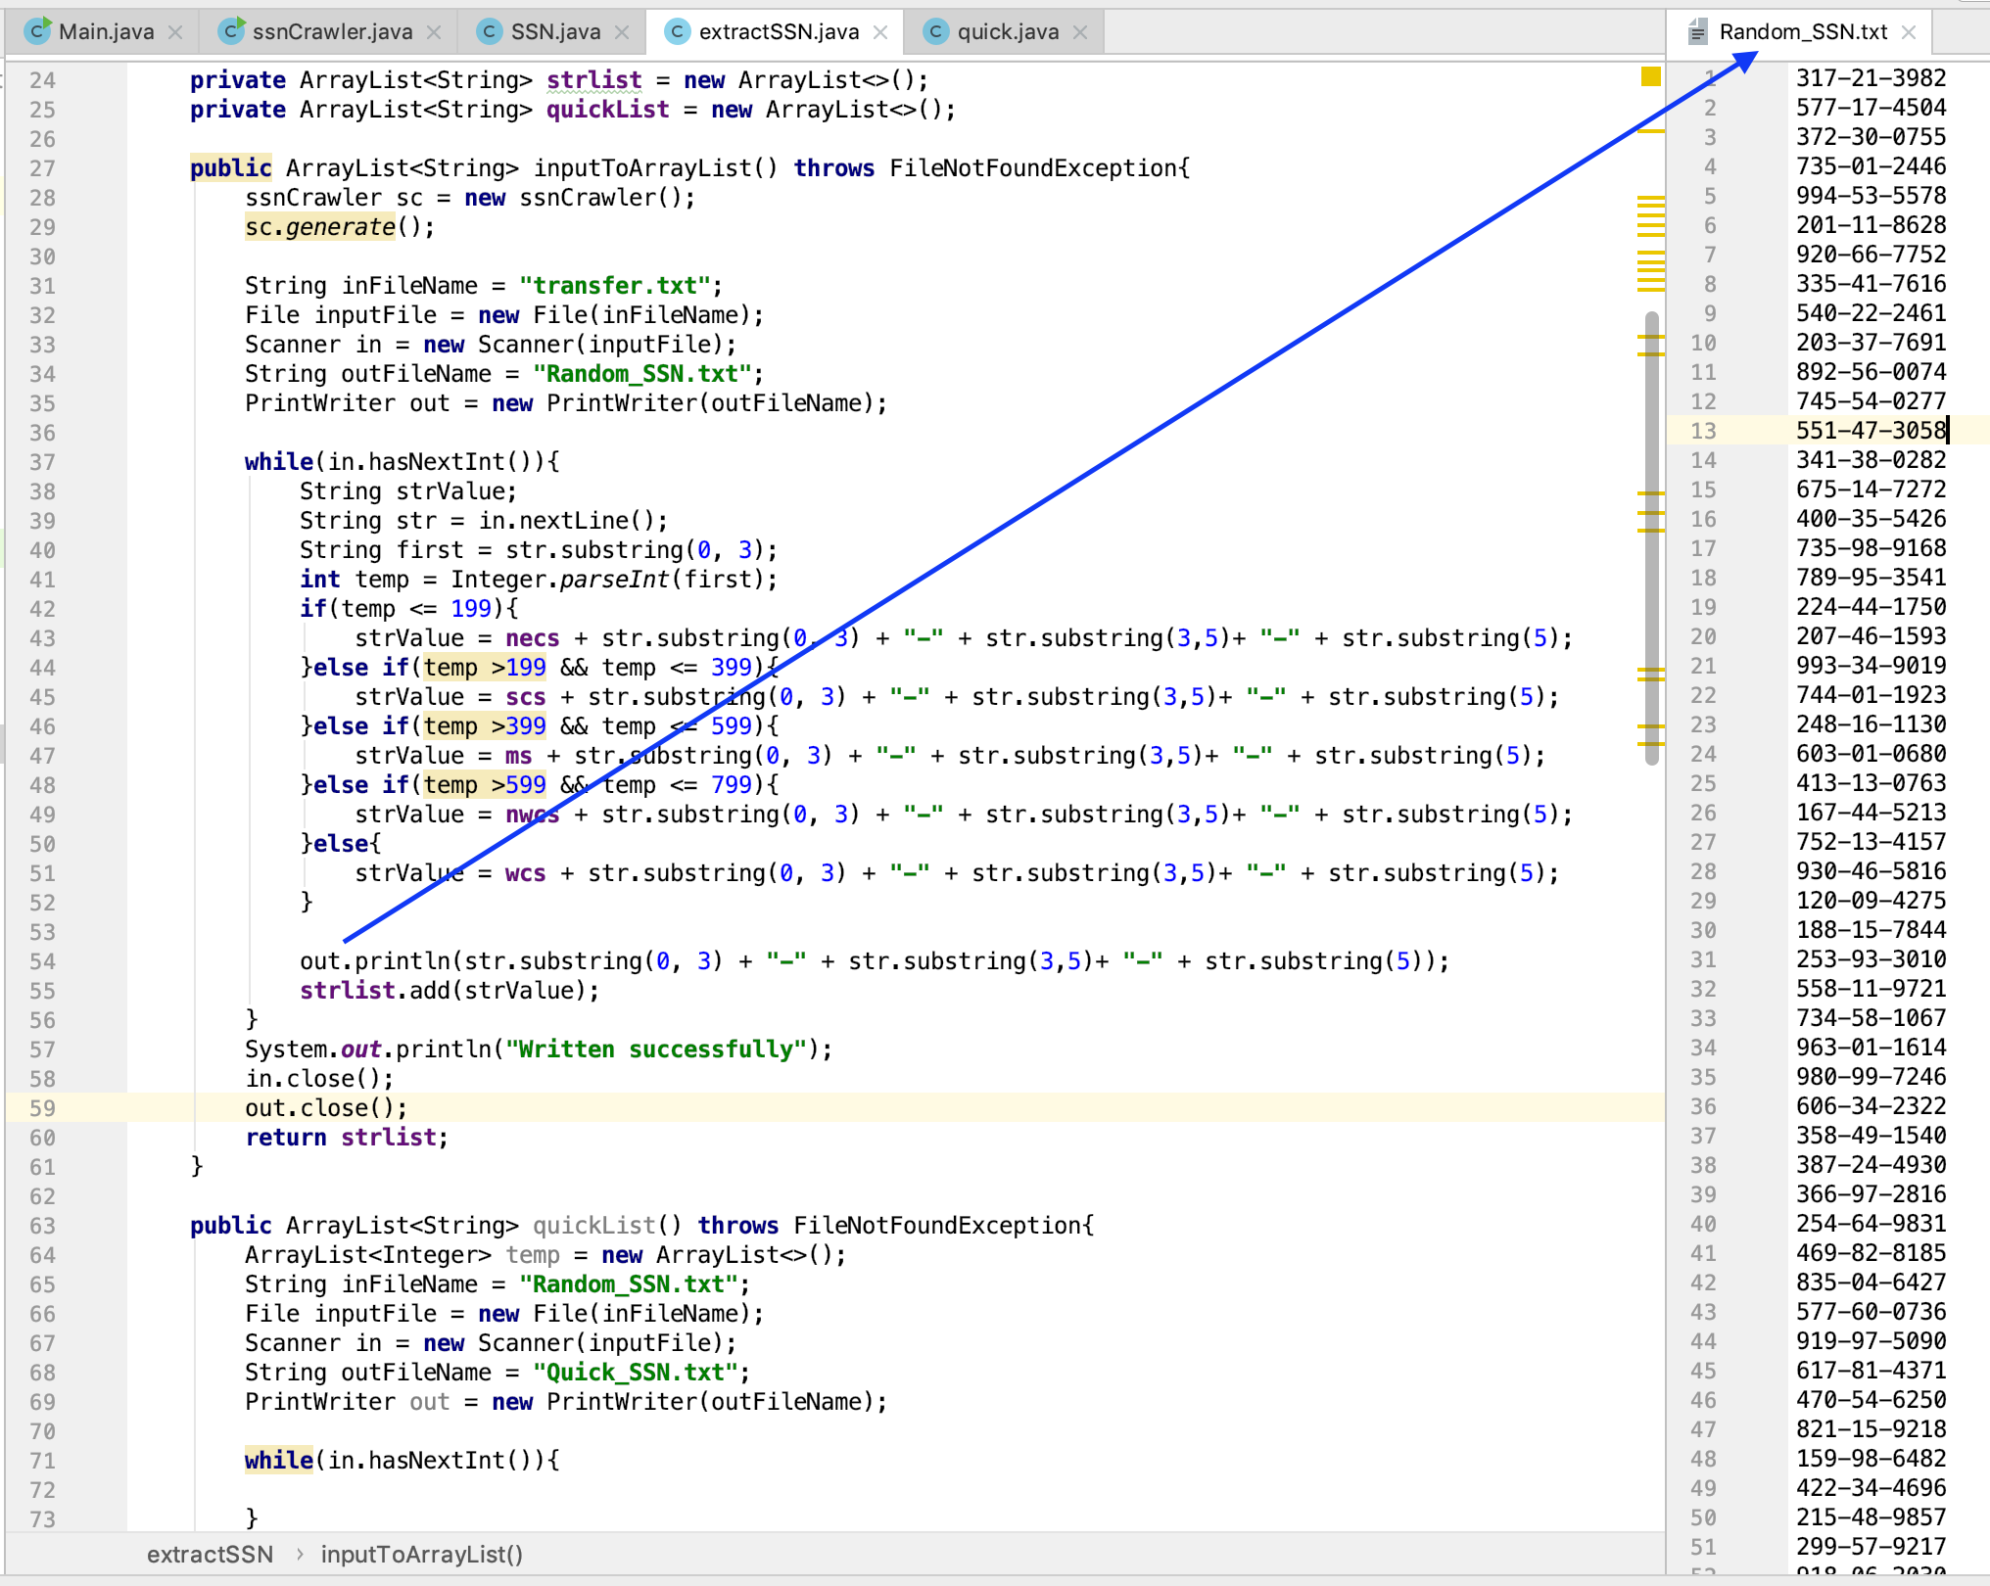

2. **public** ArrayList<Integer> quickSortToFile()

**public** ArrayList<String> quickSortToUI()

* This two methods either write **300 SSN** to the **.txt** file or display 300 SSN on the **User Interface**, see the result in the following:

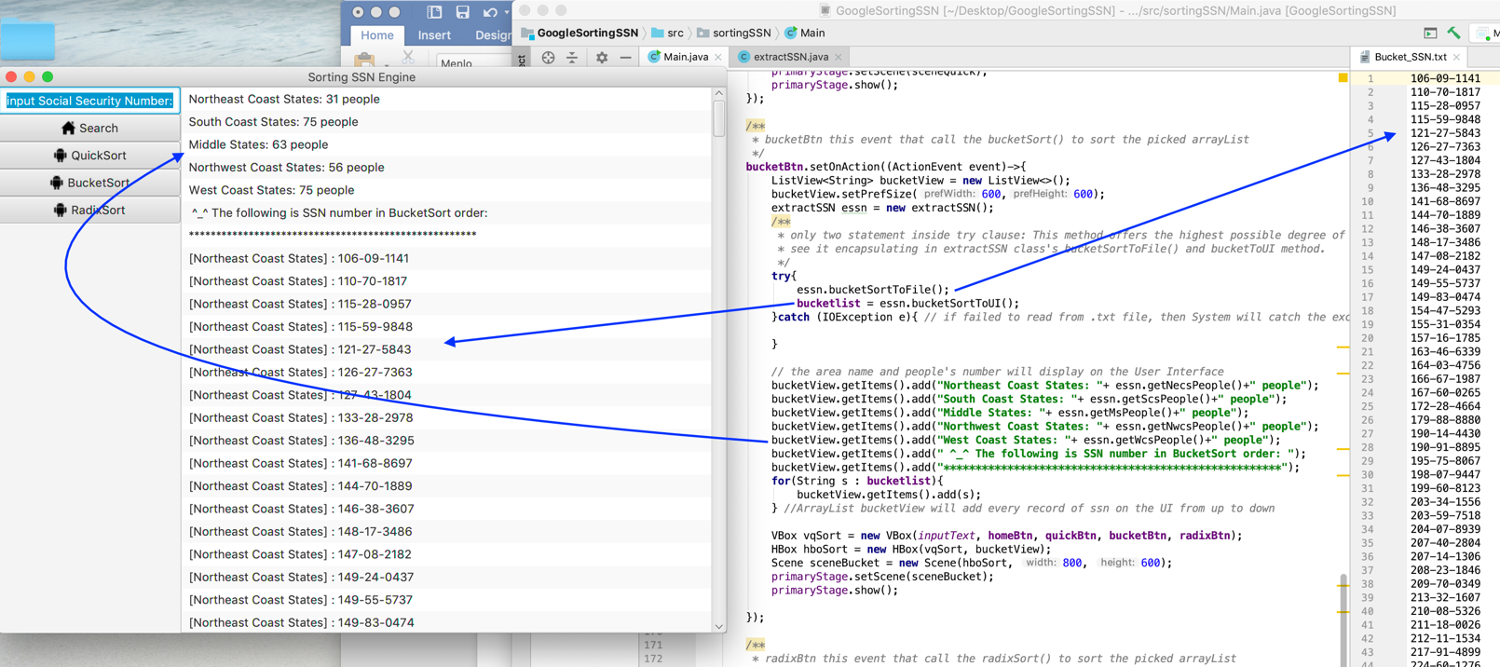

* Then I implement **quick** class for the **quickSort()** method

The main functioning, I will show in the **Part 4**: A list of **classes/subroutines**

* I also implement **bucket** class for the **bucketSort()** method

The main functioning, I will show in the **Part 4**: A list of **classes/subroutines**

* I implement **radix** class for the **radixSort()** method

The main functioning, I will show in the **Part 4**: A list of **classes/subroutines**

* After finished the above working, the Main class can implement four different required functioning:

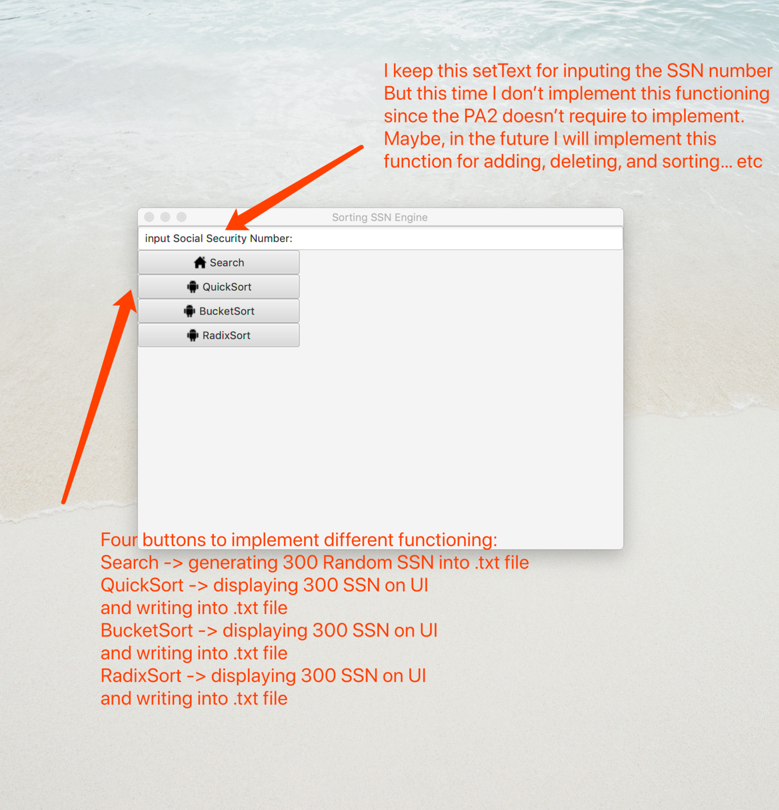

* The main User Interface will show two parts:

1. Button component with image icon
2. Console will display SSN numbers, Area name, and the number of people

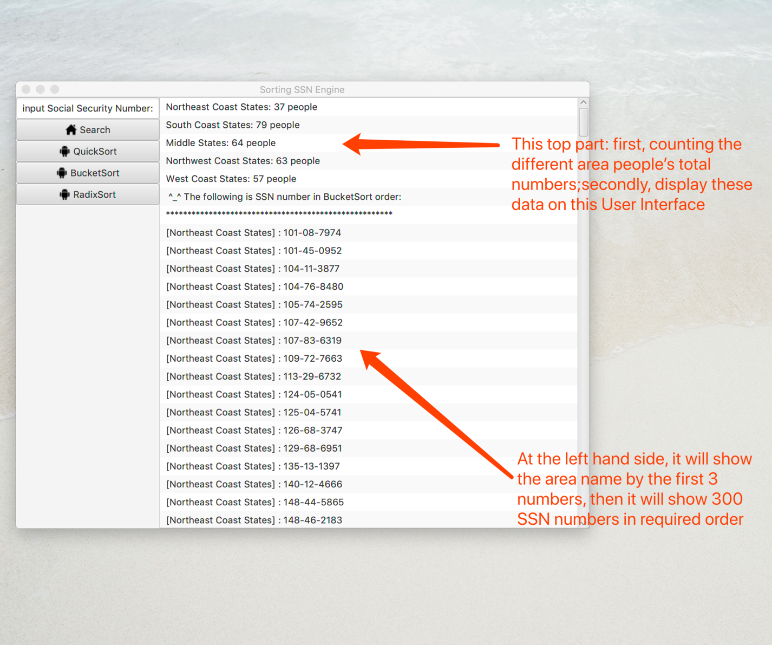

To summary: so far so good, I have **implemented** all class’s functioning.

In chapter 4, I will further explain my every class’s method, class’s subroutines, and every function calls.

4. classes/subroutines/function calls:

* In the **extractSSN** class, there is a method ArrayList<String> generateToRandom_SSN()

1. Creating a **object** of **ssnCrawler**; calling the **generate()** method to generate 300 **Random SSN** numbers.
2. The **generate()** will write 300 SSN into the **transfer.txt** ; this step’s purpose is to make **transfer.txt** be a buffered .txt file. Because without **transfer.txt**, we only read data from **Random_SSN.txt** so that we can’t see the change after we call **quickSort(), bucketSort(), and radixSort()**. Therefore, we can see the different and new SSN numbers.

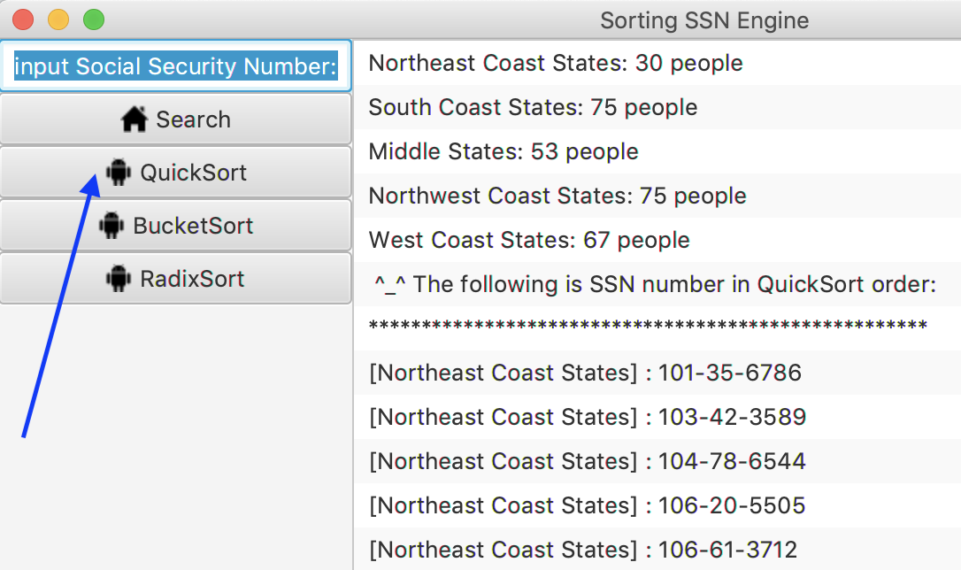

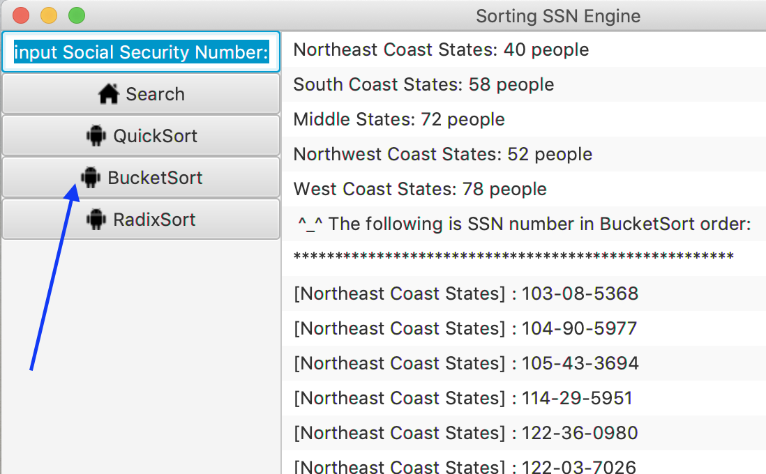

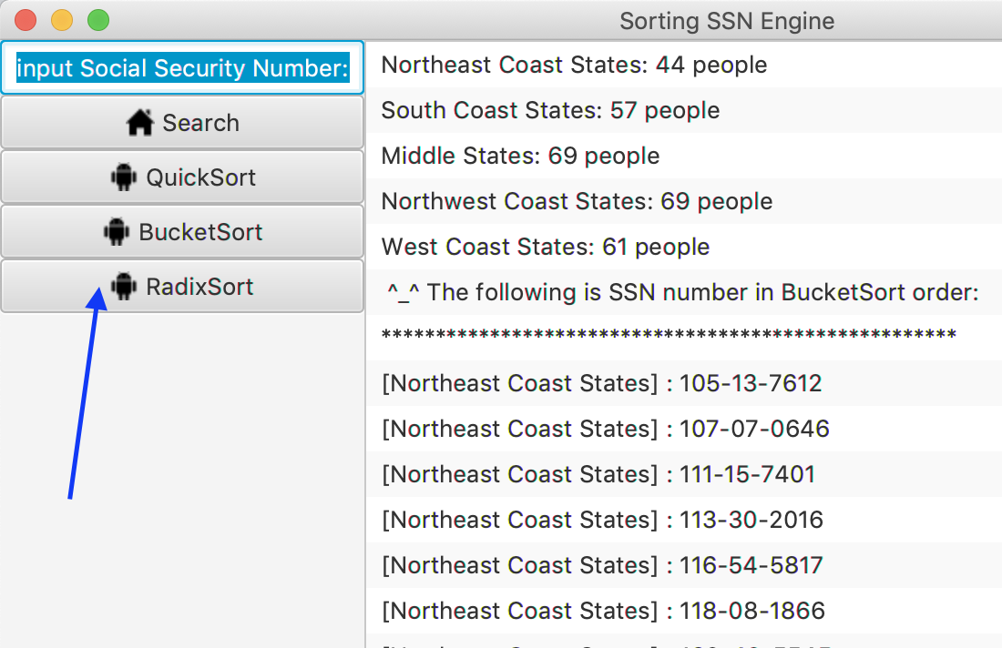

* Inside every method, there is **while()** clause, its purpose is to compare first 3 numbers:

if(temp <= 199){ *//store every ssn number with the area name* strValue = necs + str.substring(0, 3) + "-" + str.substring(3,5)+ "-" + str.substring(5);  
}else if(temp >199 && temp <= 399){  
 strValue = scs + str.substring(0, 3) + "-" + str.substring(3,5)+ "-" + str.substring(5);  
}else if(temp >399 && temp <= 599){  
 strValue = ms + str.substring(0, 3) + "-" + str.substring(3,5)+ "-" + str.substring(5);  
}else if(temp >599 && temp <= 799){  
 strValue = nwcs + str.substring(0, 3) + "-" + str.substring(3,5)+ "-" + str.substring(5);  
}else{  
 strValue = wcs + str.substring(0, 3) + "-" + str.substring(3,5)+ "-" + str.substring(5);  
}

*//write every ssn number into the Random_SSN.txt file*out.println(str.substring(0, 3) + "-" + str.substring(3,5)+ "-" + str.substring(5));

* We can distinguish the different area name:

[Northeast Coast States]

[South Coast States]

[Middle States]

[Northwest Coast States]

[West Coast States]

* out.println() will write all data into the .txt file

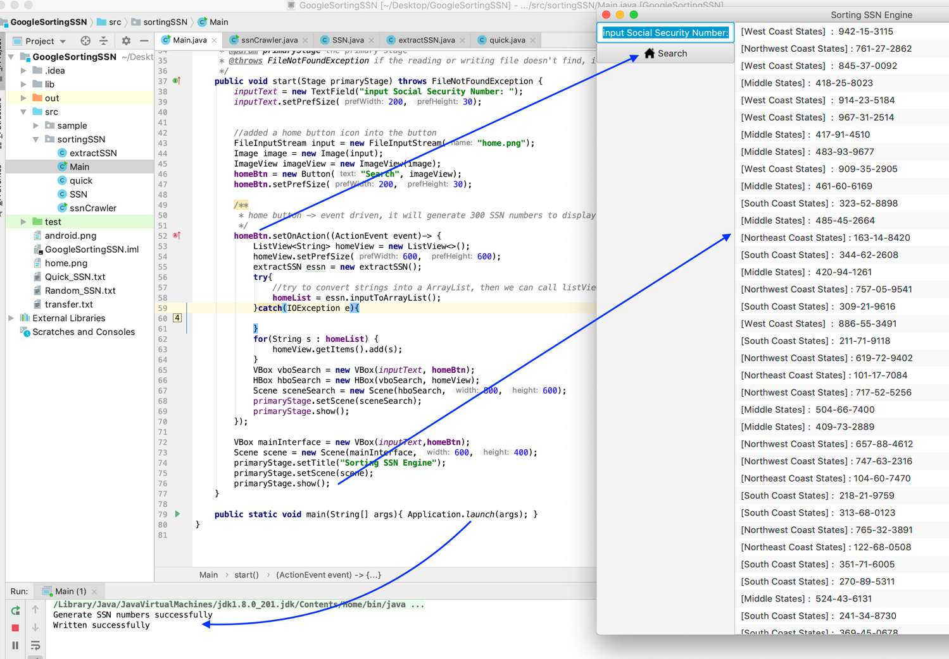

public ArrayList<Integer> quickSortToFile()

public ArrayList<String> quickSortToUI()

this two method’s purpose are to write all data into .txt file and on the User Interface:

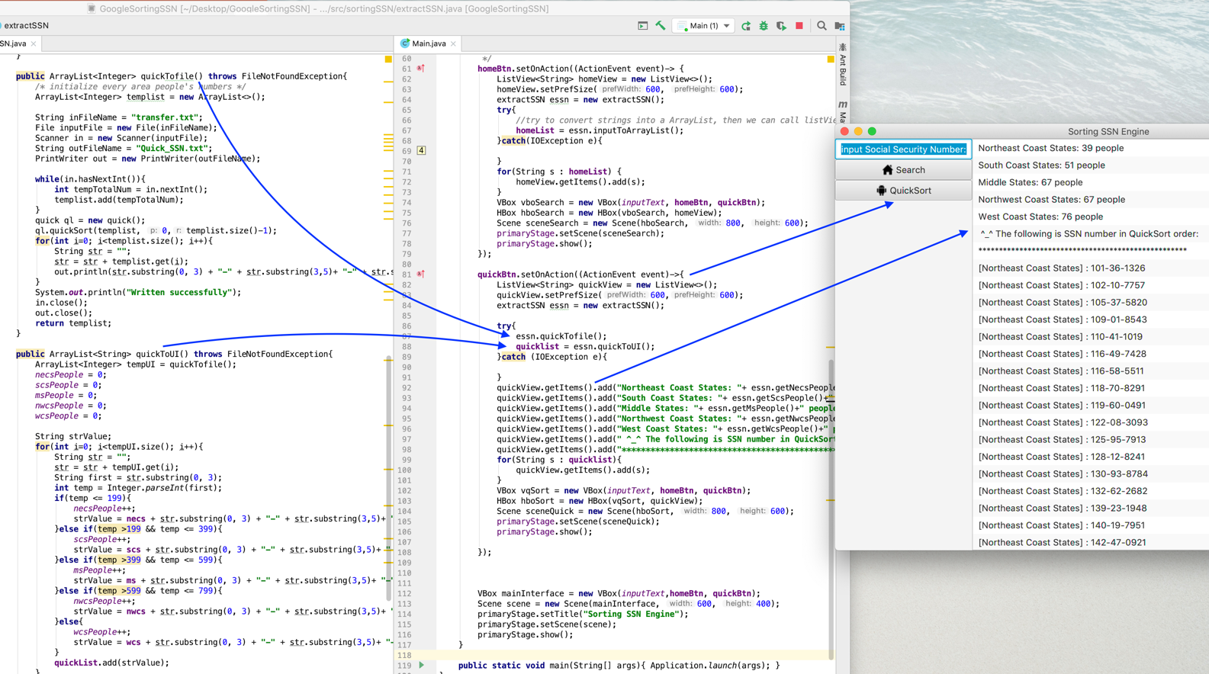

public ArrayList<Integer> bucketSortToFile()

public ArrayList<String> bucketSortToUI()

this two method’s purpose are to write all data into .txt file and on the User Interface:

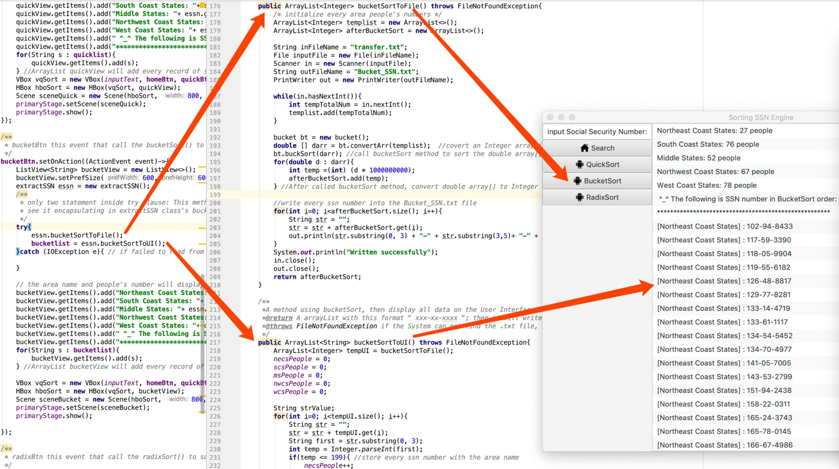

public ArrayList<Integer> radixSortToFile()

public ArrayList<String> radixSortToUI()

this two method’s purpose are to write all data into .txt file and on the User Interface:

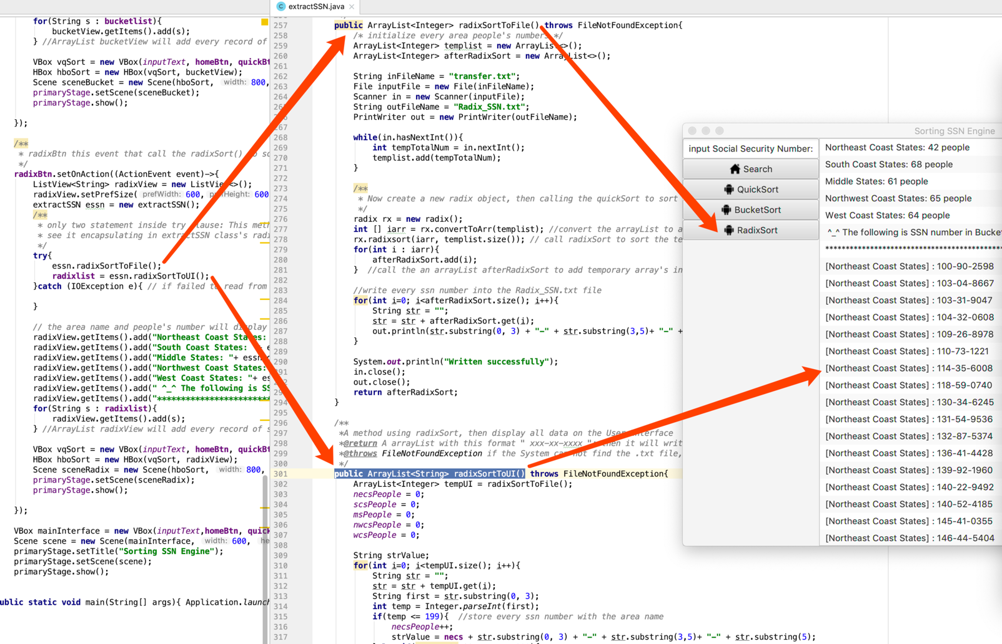

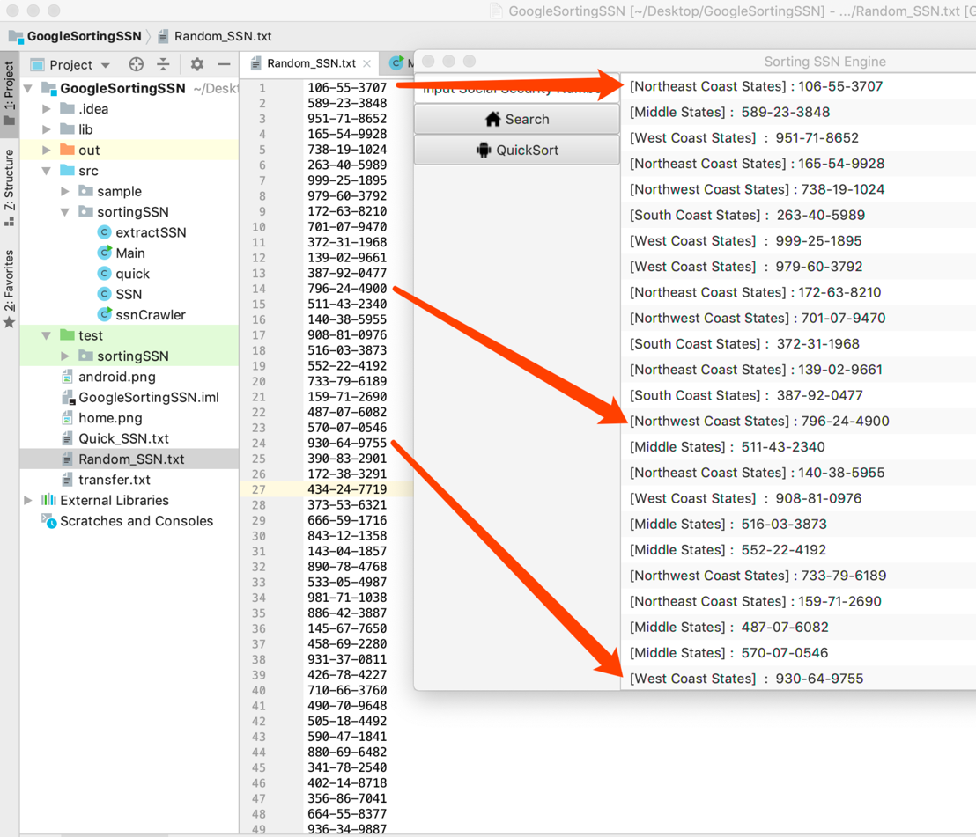

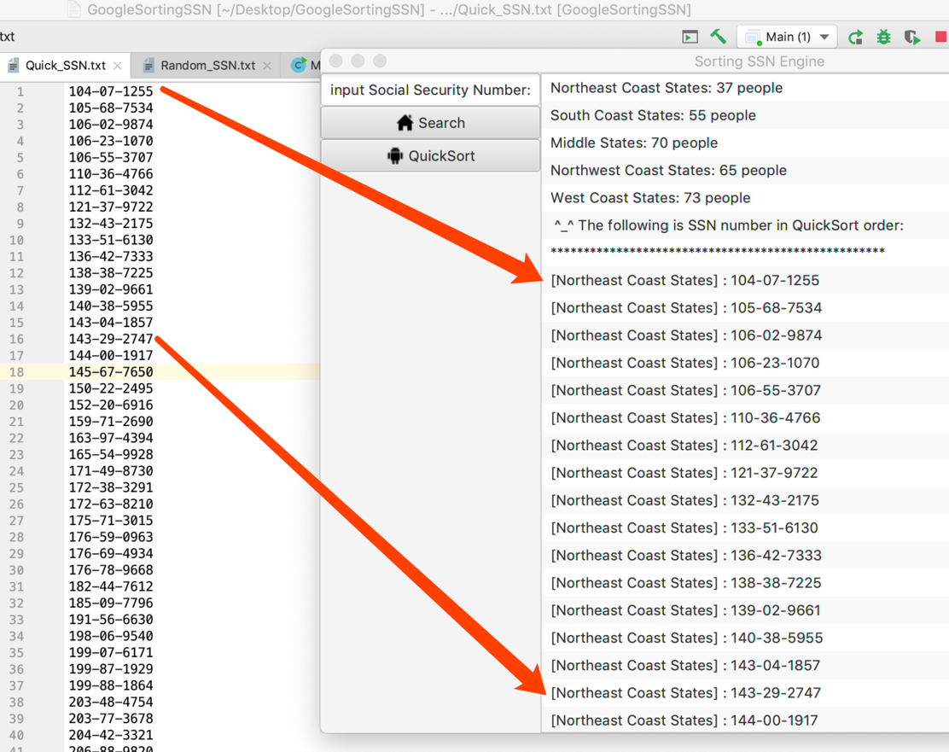

* Now I will explain how to implemnt **bucketSort()** method step by step:

*/**  
 * Convert a Integer arrayList to a double array[]  
 * @param intarr the given arrayList with Integer elements  
 * @return a double array[]  
 */*public double[] convertArr(ArrayList<Integer> intarr){  
 double [] darr = new double[intarr.size()];  
 for(int i=0; i<intarr.size(); i++){  
 darr[i] = (intarr.get(i))/ 1000000000.0;  
 }  
 return darr;  
}

1. Firstly, trying to **convert** the ArrayLsit<Integer> to the **double [] array**, this step’s purpose is to satisfies 0 <= A[i] < 1
2. Create a **double[] array** to receive the converted data
3. Using original arrayList’s size()

* For here, the original arrayList’s size() is **300**
* So we set **n = size() = 300**

1. **Every int element** / 1000000000.0; this step’s purpose is to make

**every new element** <= **1**  and new element is a **double**

5. Inside **buckSort(double [] arr)** method, we call a

ArrayList<Double>[] bucketList = **new** ArrayList[n];

**bucketList** is an **array**, which every **array[i]** contains a **arrayList**

* **Array[i].arrayList<Double>**

*/**  
 * insert every double element into the appropriate index of bucketList  
 */*for(int i=0; i<n; i++){  
 int bucketIndex = (int)(arr[i] * n);  
 bucketList[bucketIndex].add(arr[i]);  
}

* Set every **bucketIndex = every double elment * 300**
* For example: **0.456228899** * **300** = 136.8686697
* Convert: **(int)** 136.8686697 => **136**
* Finally, **bucketIndex = 136**
* Calling the array[] **bucketList[136].add(double elment);**

*/**  
 * calling the insertSort to sort every arrayList  
 */*for(int i=0; i<n; i++){  
 insertSort(bucketList[i]);  
}

6. loop a size = 300, everytime calling the **insertSort()** to help sort every bucket’s double

element:

* We have known this step is stable.
* The **insertSort()** will compare the every double element in this **bucketList[bucketIndex]**

7. the following is the graphically explaination:

0.456229999

0.456228899

|  |  |
| --- | --- |
|  |  |
|  |  |
|  |  |
|  |  |
|  |  |
| 100 |  |
|  |  |
|  |  |
|  |  |
|  |  |
|  |  |
|  |  |
|  |  |
| 136 |  |
|  |  |
|  |  |
|  |  |
|  |  |
|  |  |
|  |  |

*/* concatenate all buckets */*int index = 0;  
for(int i=0; i<n; i++){  
 for(int j=0; j<bucketList[i].size(); j++){  
 arr[index++] = bucketList[i].get(j);  
 }  
}

Finally, use **two for** loop to **concatenate** all buckets, this step is like 2D array operation.

* Done!
* Now I will explain how to implemnt **radixSort()** method step by step:

*/**  
 * @param arr the required arrayList to convert to a integer array  
 * @return a new integer array  
 */*public int[] convertToArr(ArrayList<Integer> arr){  
 int [] iarr = new int[arr.size()];  
 for(int i=0; i<arr.size(); i++){  
 iarr[i] = arr.get(i);  
 }  
 return iarr;  
}

* Convert **ArrayList<Integer>** to **int[ ]** , the reason why I convert the arrayList because arrayList is difficult to **manipulate.**

*/**  
 * Get the maximum from this array  
 * @param arr the required array will be sorted  
 * @param n the length of this array  
 * @return a maximum  
 */*public int getMax(int arr[], int n){  
 int max = arr[0];  
 for(int i=1; i<n; i++){  
 if(arr[i] > max){  
 max = arr[i];  
 }  
 }  
 return max;  
}

* Find the max length, this step is to find the max places
* For example 10’s => 100’s => 1000’s => 10000’s => … …

*/**  
 * The helper method to help radixSort to sort the SSN number  
 * @param arr the required array  
 * @param n the array's lenght  
 * @param places the every digit place  
 */*public void countSort(int arr[], int n, int places){  
 int B[] = new int[n];  
 int count[] = new int[10];  
 */* initialize every element to be 0 */* Arrays.*fill*(count,0);  
  
 */* count every digit from 0-9 that the number of times of appearance */* for(int i=0; i<n; i++){  
 count[ (arr[i]/places)%10]++;  
 }  
  
 *//updated the array C[]* for(int j=1; j<10; j++){  
 count[j] = count[j] + count[j-1];  
 }  
  
 *//input the sorted number into the appropriate index* for(int j=n-1; j>=0; j--){  
 B[count[(arr[j]/places)%10]-1] = arr[j];  
 count[ (arr[j]/places)%10 ]--;  
 }  
  
 *//copy the new array to the original array* for(int i=0; i<n; i++){  
 arr[i] = B[i];  
 }  
}

In the **countSort()** method, count every digit from 0-9 that the times of this number’s apperance:

* Arr[i] / places => find the **nth** place
* %10 => find one of the 0-9 digit
* finally, update the times of this number appearing
* Put the sorted number into the appropriate index, then update the **count array**
* **Note:** copy the new array to the original array.
* The following table will show the theory to implement **radixSort() :**

|  |  |  |  |  |
| --- | --- | --- | --- | --- |
| Index | Original | One’s place | 1000’s place | 100xxxxxx’s place |
| 1 | 751345555 | 592679900 | … | … |
| 2 | 543456789 | 239671111 |  |  |
| 3 | 689234545 | 961567711 |  |  |
| 4 | 264245566 | 799990011 |  |  |
| 5 | 837349988 | 393778811 |  |  |
| 6 | 160783434 | 937882222 |  |  |
| 7 | 239671111 | 177789732 |  |  |
| 8 | 937882222 | 236567823 |  |  |
| 9 | 592679900 | 160783434 |  |  |
| 10 | 961567711 | 885993344 |  |  |
| 11 | 799990011 | 412356784 |  |  |
| 12 | 885993344 | 751345555 |  |  |
| 13 | 393778811 | 689234545 |  |  |
| 14 | 177789732 | 264245566 |  |  |
| 15 | 236567823 | 747234567 |  |  |
| 16 | 364117799 | 837349988 |  |  |
| 17 | 412356784 | 543456789 |  |  |
| 18 | 747234567 | 364117799 |  |  |

5. Self-testing

* Testing ssnCrawler.generate() :

Generating 300 SSN numbers without sorting

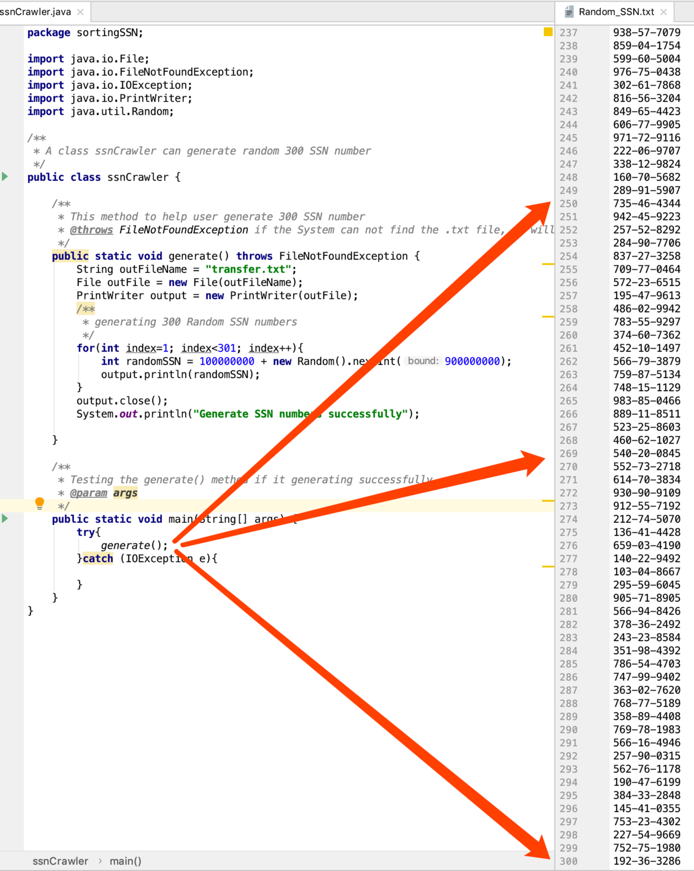

* Testing Main class

1. testing four **button icon**:

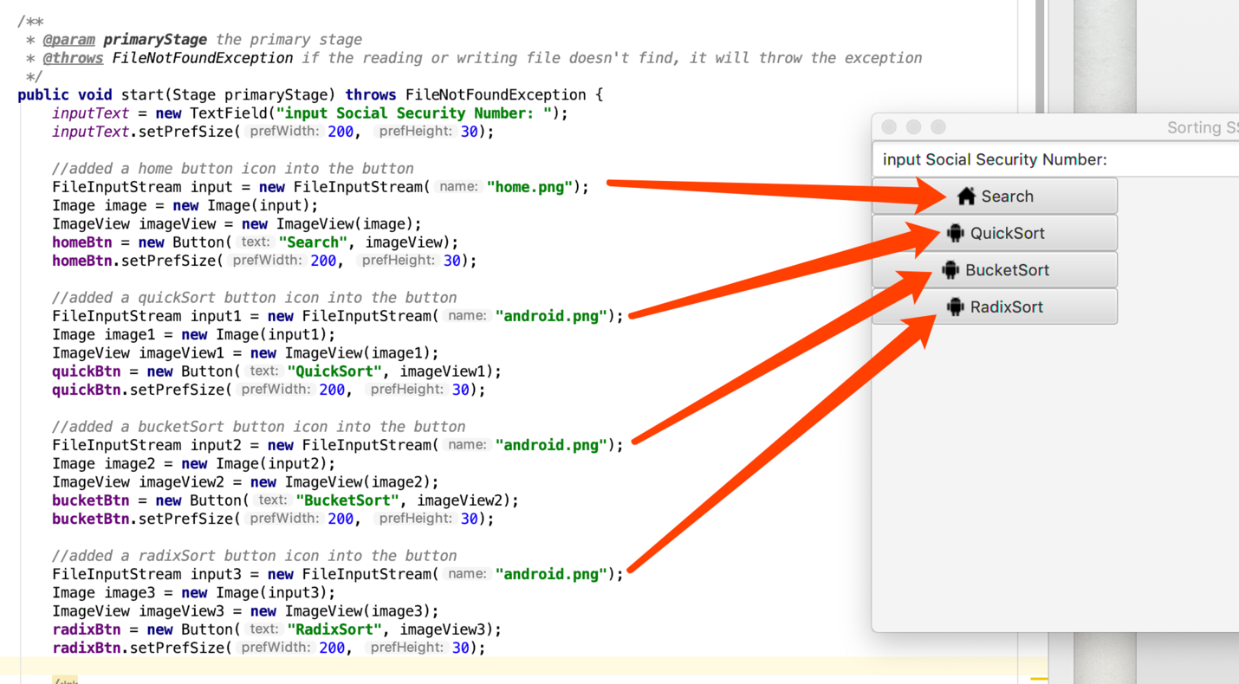

2. testing **ListView()**  , which will drive the button event to display on the **User Interface**:

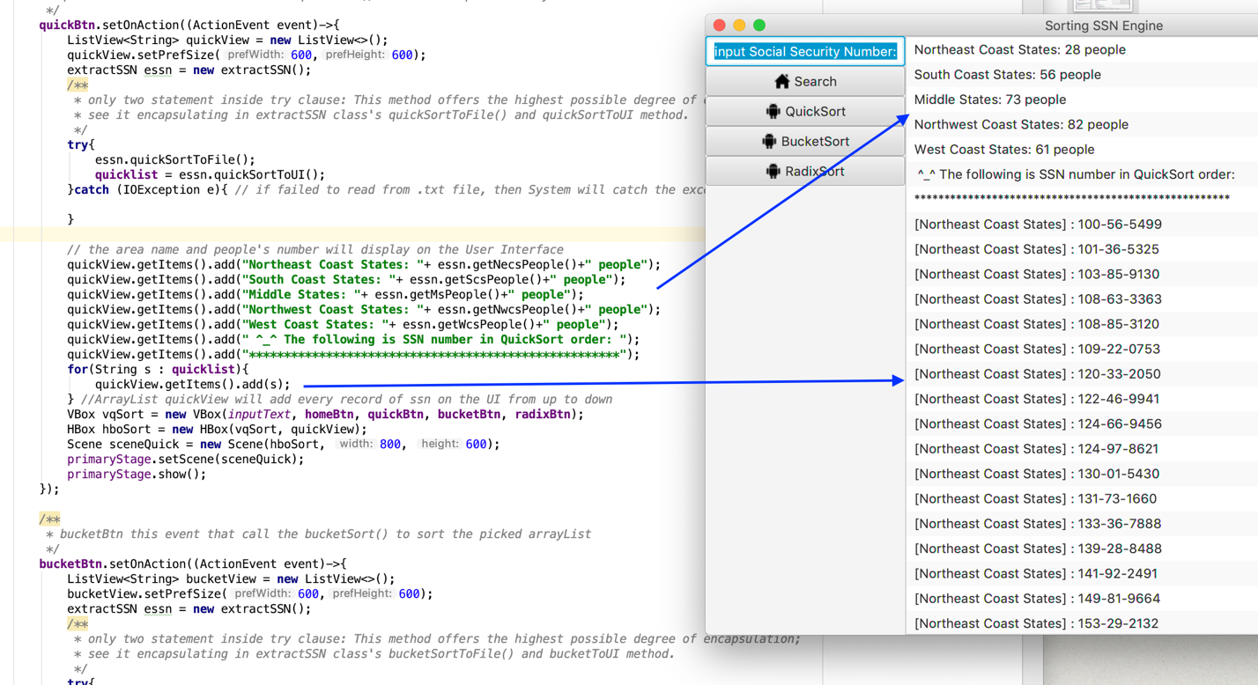

* Testing **primaryStage.setTitle() primaryStage.setScene()primaryStage.show()**

Testing **Application.launch(args)** , the previous 4 method will construct a **primary stage** , you will see a **framework** with **title**, **button**, **icon**, and **data** :

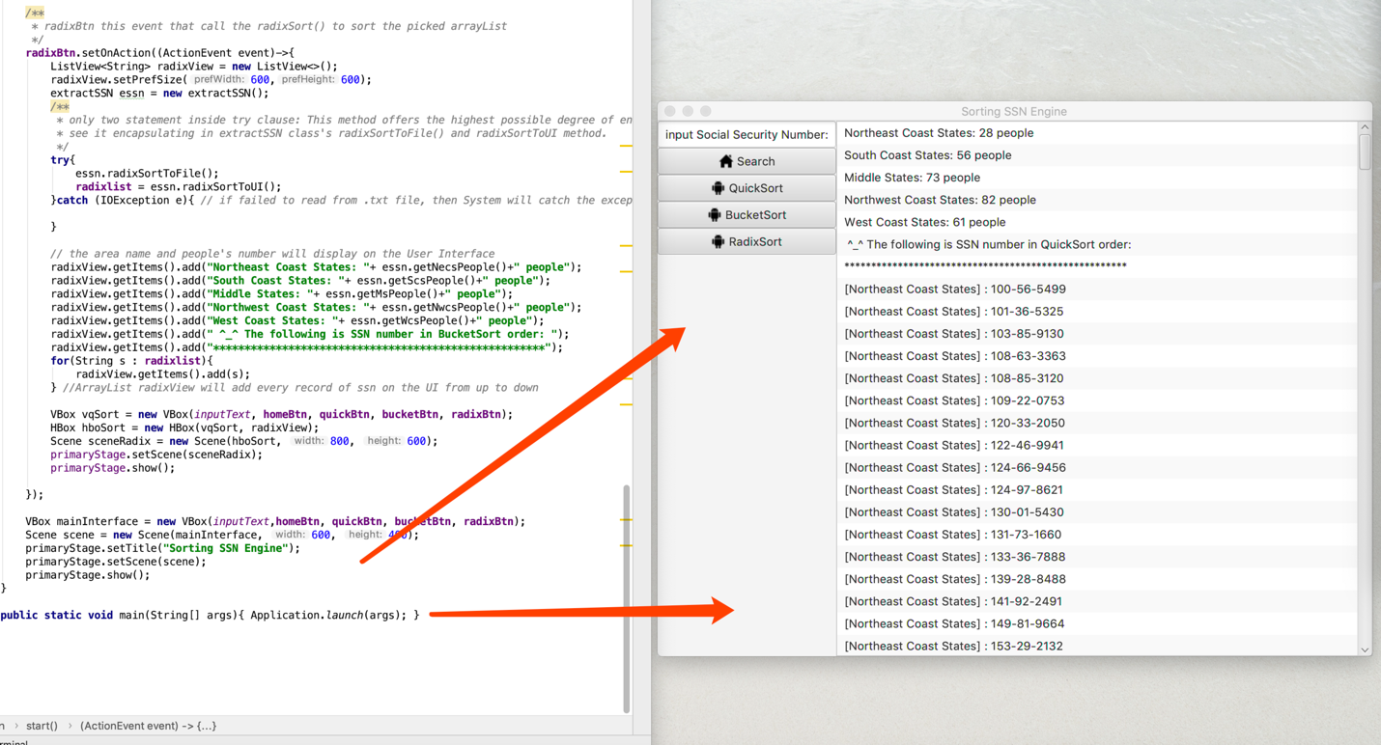

* Testing **bucketSort()** method:

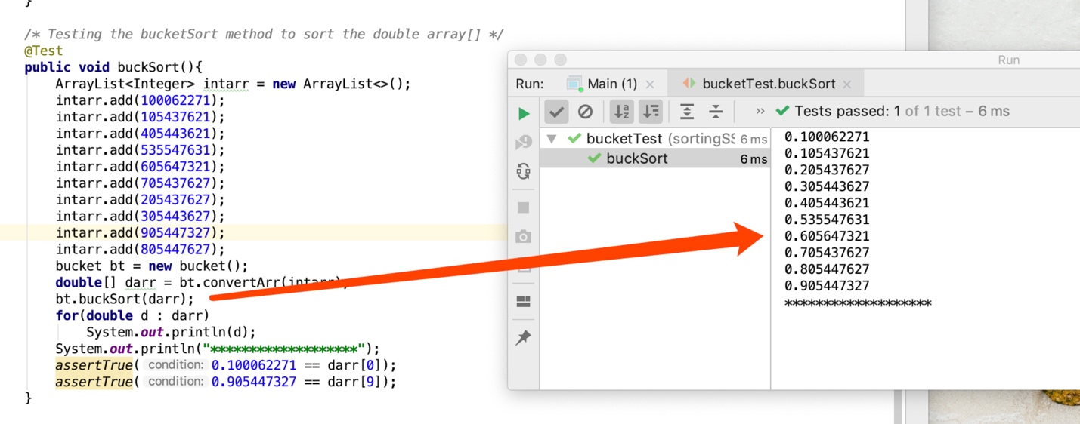

* Testing the quick class’s **partition()** method :

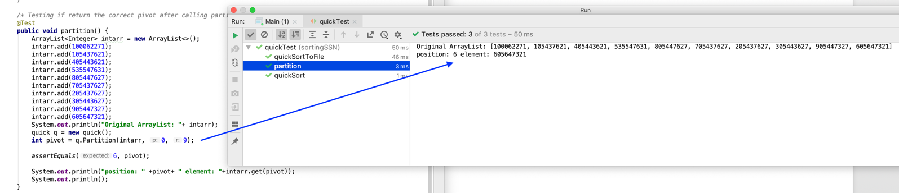

* Testing **quickSort()** method:

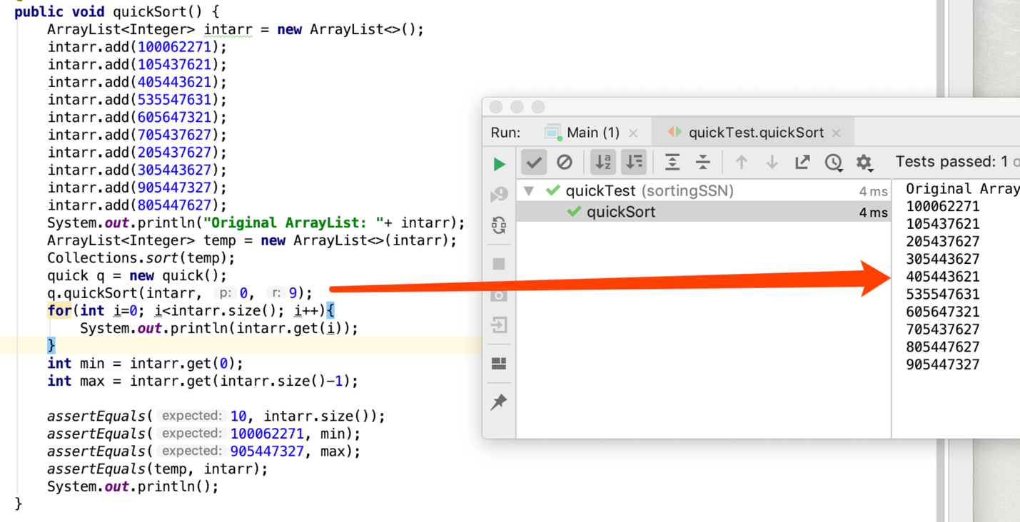

* Testing **radixSort()** method:

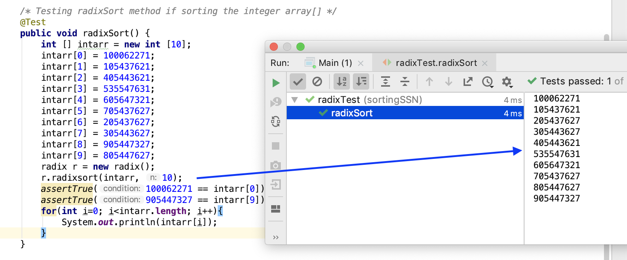

To summary: the **remaining** **Running time** and some **detail** , I will illustrate in **Part 8**:

Running Time Big- $Ο$ (Junit -Test)

6. Problems encountered during implementation

* Since I design my program can do two things, I found that it is difficult to display all sorted data on the UI and .txt file at the same time.
* Originally, for example, I combined AfterQuickSortToFile() and AfterQuickSortToUserInterface() this two methods into one method:

1. problem_1: if I did like this, it will increase its running time because I should use some for loop, and inside for() that I need to compare 300 SSN number, whatever

what functioning I want to implement, it always occur at the same time.

2. problem_2: it is very hard to mainpulate these data structures, since some bucketSort radixSort which I convert arrayList to Array; then after did this step, I convert the Array to arrayList.

This is a most troublesome case: you should care the data structure that you using and you should focus on which functioning that you want to implement: on UI and into .txt file.

* Look this following piece of codes:

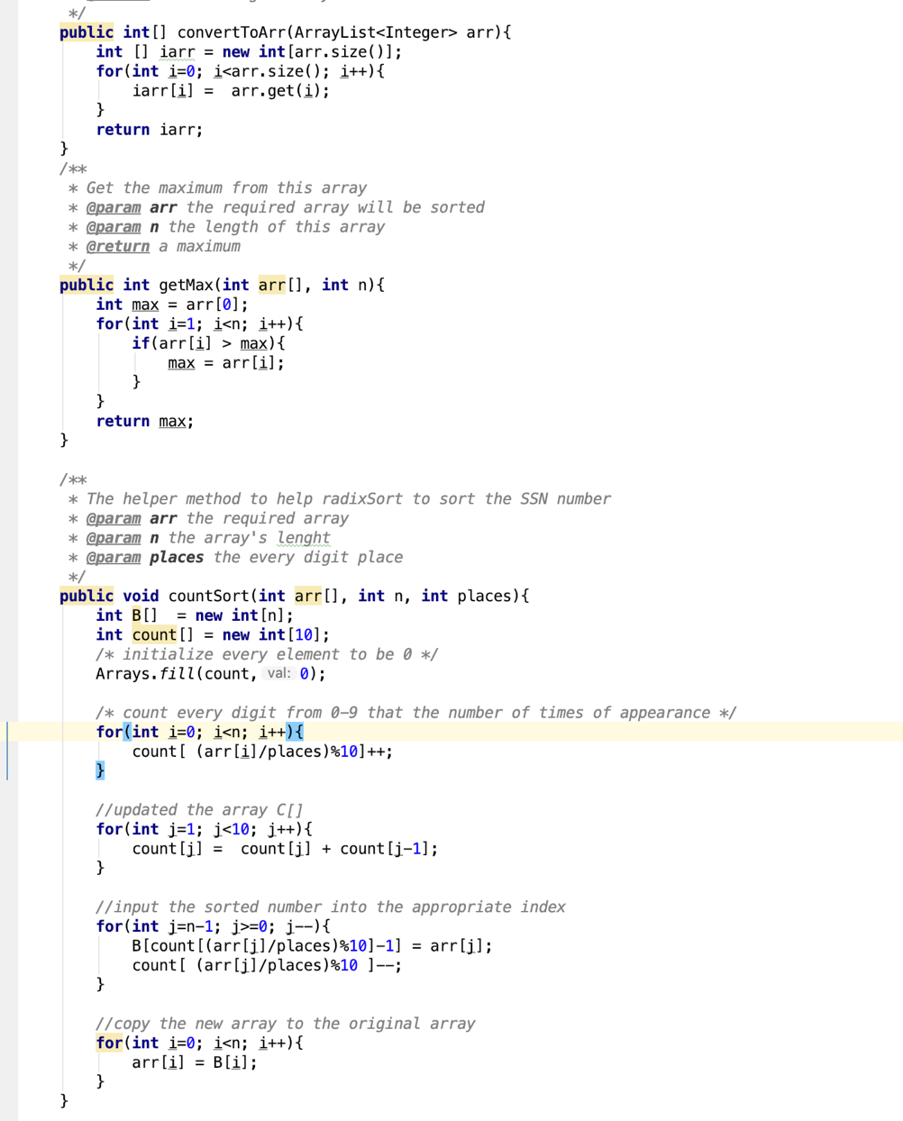

* And this following codes also illustrate the problem that I will encounter:

quickBtn.setOnAction((ActionEvent event)->{

ListView<String> quickView = new ListView<>();  
quickView.setPrefSize(600,600);  
extractSSN essn = new extractSSN();  
try{  
 essn.quickSortToFile();  
 quicklist = essn.quickSortToUI();  
}catch (IOException e){ *// if failed to read from .txt file, then System will catch the exception*}

quickBtn.setOnAction((ActionEvent event)->{  
 ListView<String> quickView = new ListView<>();  
 quickView.setPrefSize(600,600);  
 extractSSN essn = new extractSSN();

try{  
 essn.bucketSortToFile();  
 bucketlist = essn.bucketSortToUI();  
}catch (IOException e){ *// if failed to read from .txt file, then System will catch the exception*}

bucketBtn.setOnAction((ActionEvent event)->{  
 ListView<String> bucketView = new ListView<>();  
 bucketView.setPrefSize(600,600);  
 extractSSN essn = new extractSSN();

try{  
 essn.radixSortToFile();  
 radixlist = essn.radixSortToUI();  
}catch (IOException e){ *// if failed to read from .txt file, then System will catch the exception*}

* Final **strategy**:

**Encapsulation**——**separating one** method into **two** methods, then encapsulating all these methods into the **extractSSN** class.

For example:

Only two statemente(sentences) inside Main class’s **try()** clause: this method offers the highest possible degree of encapsulation; see it encapsulating in **extractSSN** class’s **bucketSortToFile()** and **bucketSortToUI** methods.

Look the following piece of codes:

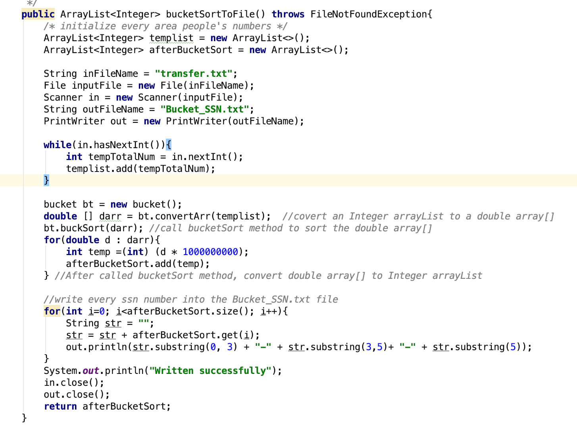

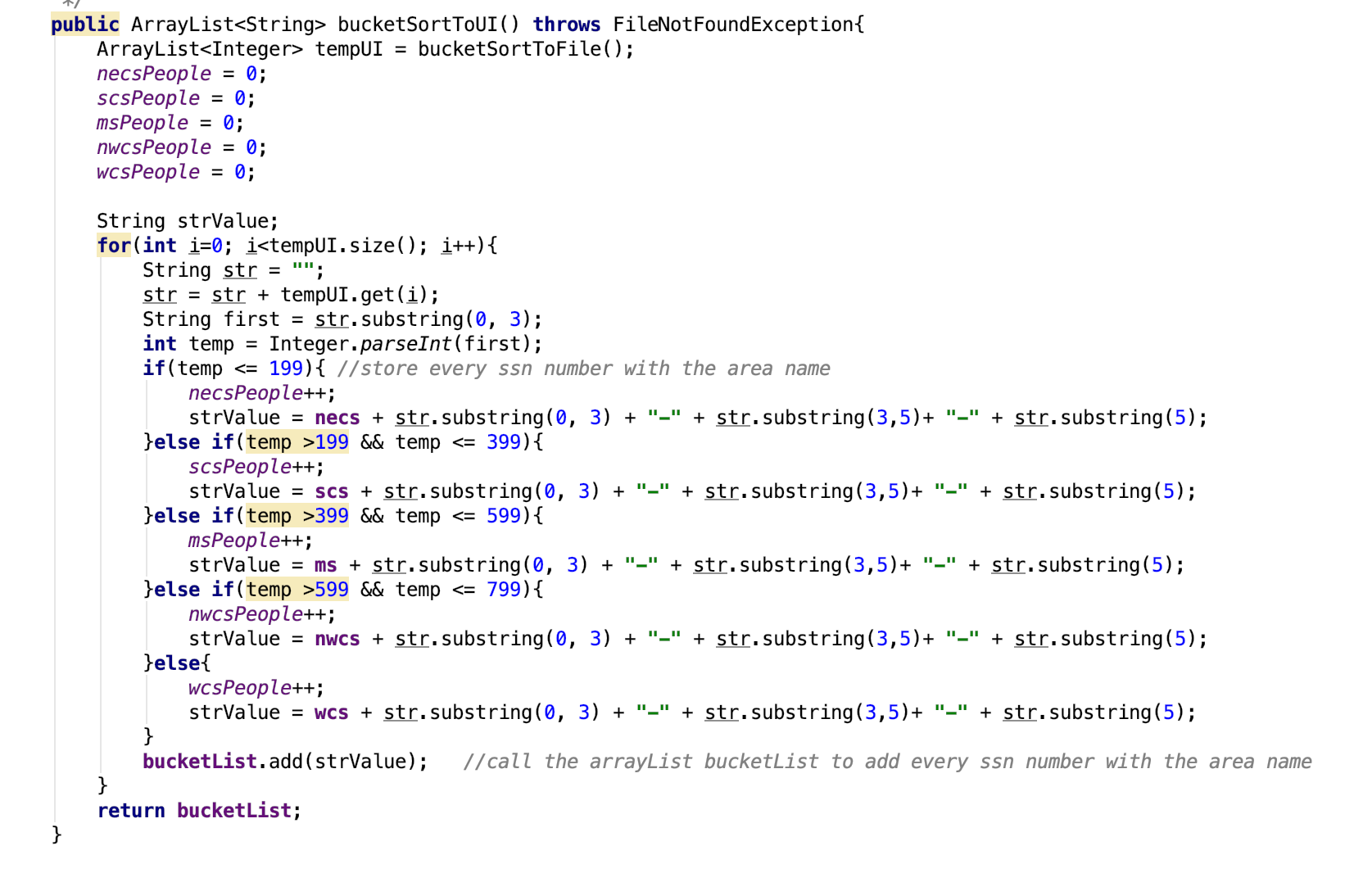

* Change Data Type:

In **radix** class, I must convert the data type:

public class radix {  
  
 */**  
 * @param arr the required arrayList to convert to a integer array  
 * @return a new integer array  
 */* public int[] convertToArr(ArrayList<Integer> arr){  
 int [] iarr = new int[arr.size()];  
 for(int i=0; i<arr.size(); i++){  
 iarr[i] = arr.get(i);  
 }  
 return iarr;  
 }

In **bucket** class, I must covert **ArrayList<Integer>** to **double array[]** :

public class bucket{  
 */**  
 * Convert a Integer arrayList to a double array[]  
 * @param intarr the given arrayList with Integer elements  
 * @return a double array[]  
 */* public double[] convertArr(ArrayList<Integer> intarr){  
 double [] darr = new double[intarr.size()];  
 for(int i=0; i<intarr.size(); i++){  
 darr[i] = (intarr.get(i))/ 1000000000.0;  
 }  
 return darr;  
 }

To summary: there is still a way that I learn from textbook and the previous CS course, can address there problems.

7. Leasson Learned

* Import **Javafx** library
* Improt **Java jdk 8**
* Import **Junit Test**
* Learned to debug some problems that I encountered
* Learned to encapsulate all methods into a class **extractSSN**
* Learned to convert data structure : convert **ArrayList to Array**

and convert **Array to ArrayList**

* For **buketSort()**

1. convert **ArrayList<Integer>** to **double[ ]**

2. calling the **insertSort()** to help implement **bucketSort()**

3. learned to explain and illustrate to show my design a bucket for **bucketSort()**

* For **radixSort()**

1. convert **ArrayList<Integer>** to **int[ ]**

2. calling the **countSort()** to help implement **raidxSort()**

3. learned to explain and illustrate to define a digit for my **radixSort()**

8. Running Time Big- $Ο$ (Junit -Test)

* **Install** :

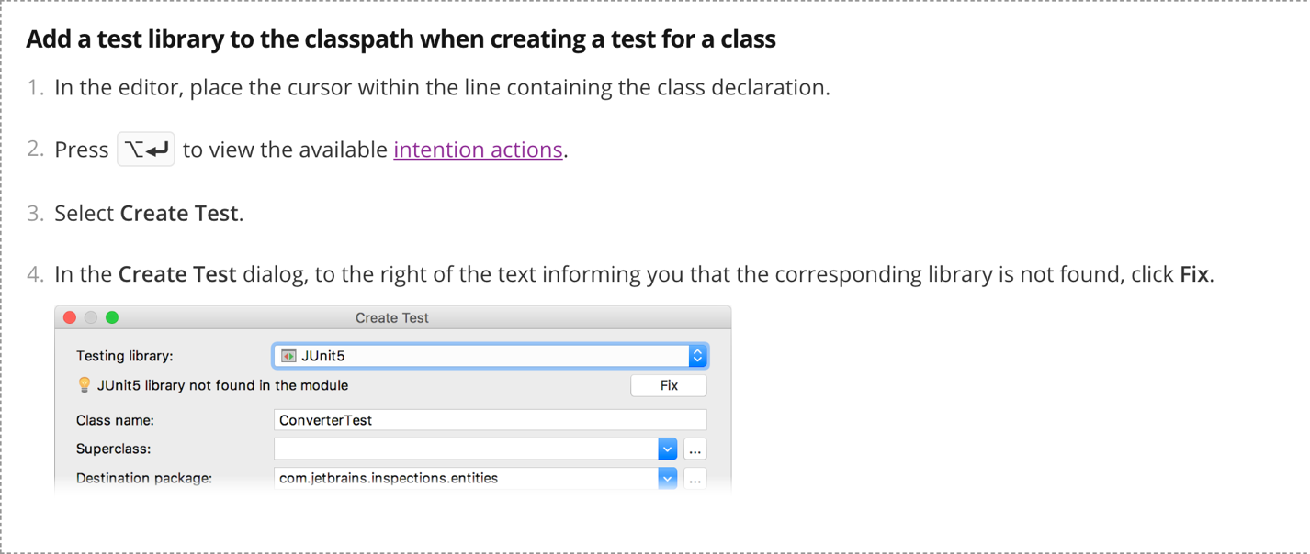

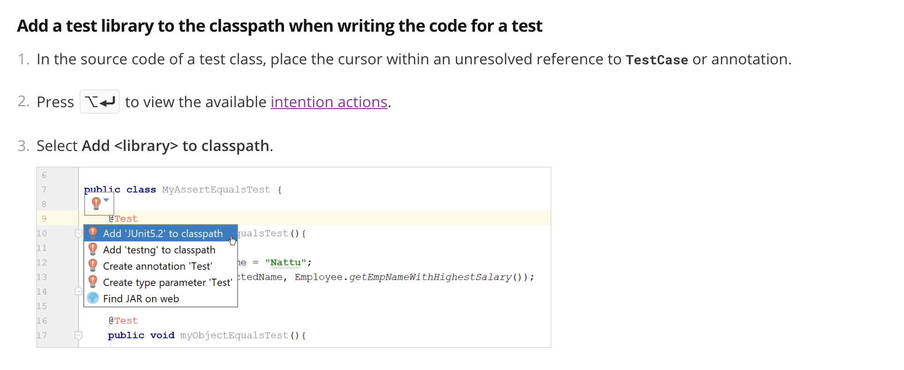

* All **Junit Test** .java files should be inside the **test** folder

Note: the **folder name** depends on your choice

The path should be like the following:

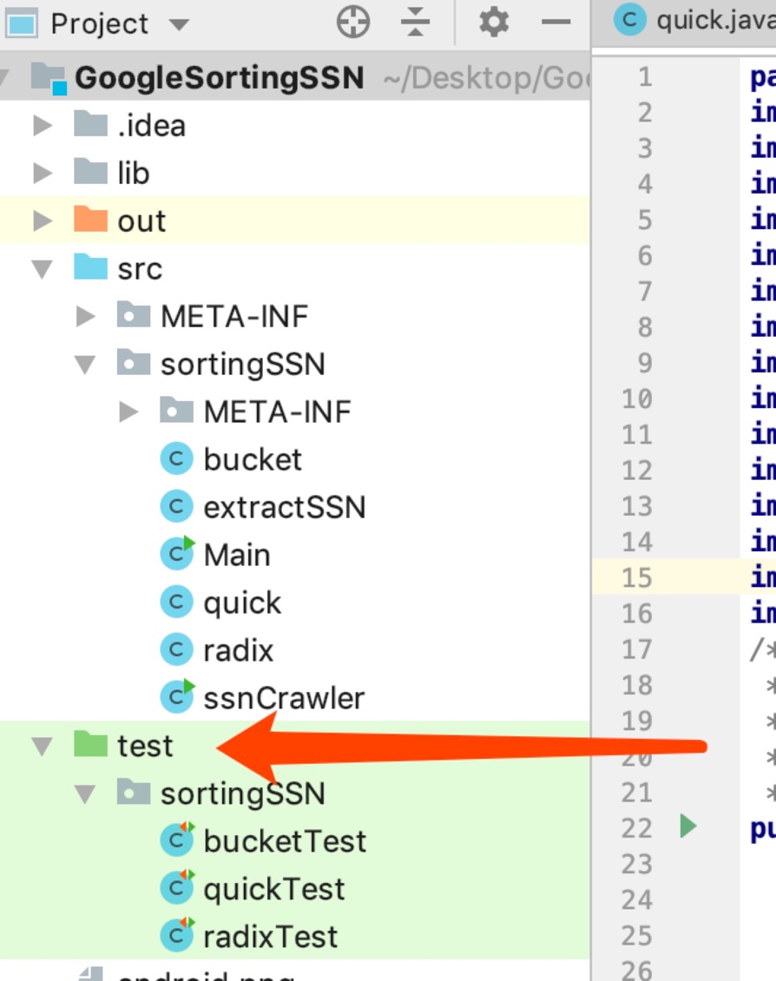

* If you are installing like the above steps, that means you have installed successfully.
* The following I take it from 10 times’s running, I extract the middle data from 10 times
* I picked the same 10 **SSN numbers**, then I will guarantee fairness.
* I picked the **300** SSN numbers that the **ssnCrawler** class generated, to write into the .txt file
* Including **quickSort bucketSort radixSort**
* For **quickSort()** :

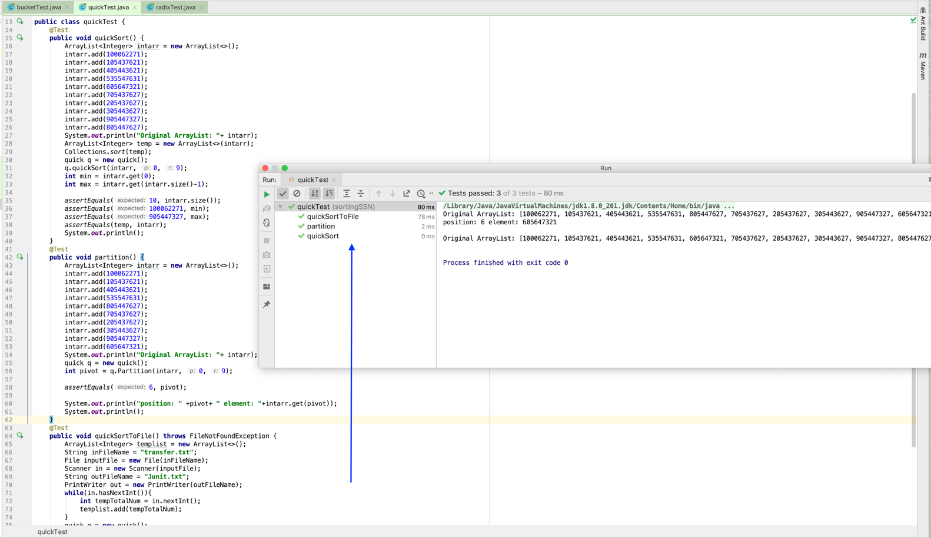

Hence for here, QuickSort’s running time:

* All quickTest : **80 ms**
* Partition: **2 ms**
* Since within Partition() , it will compare the data
* QuickSort’s average running time is $Ο$ (nlgn)
* The wrost case running time is (n2)
* For bucketSort()

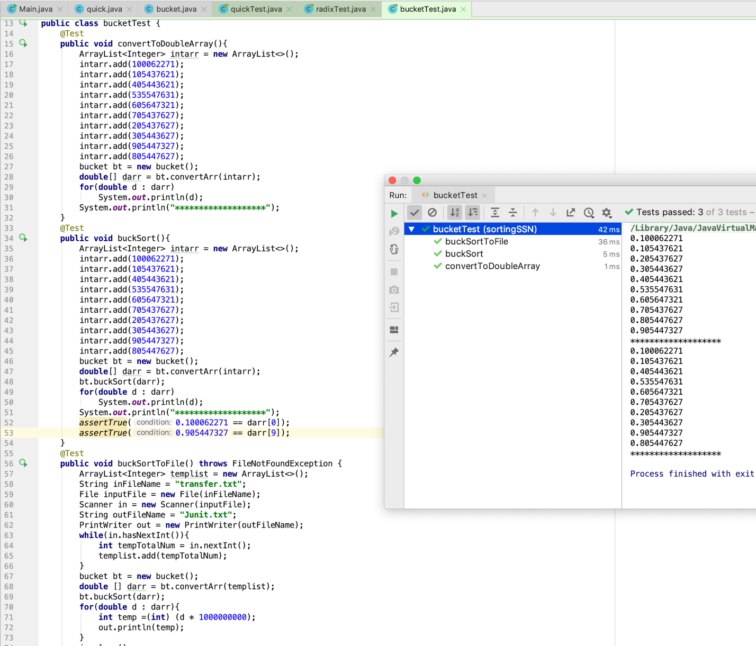

Hence for here, BucketSort’s running time:

* All bucketTest : **42 ms**
* buckSort: **5 ms**
* bucketSort’s worst case running time is $Ο$ (n)
* For **radixSort()** :

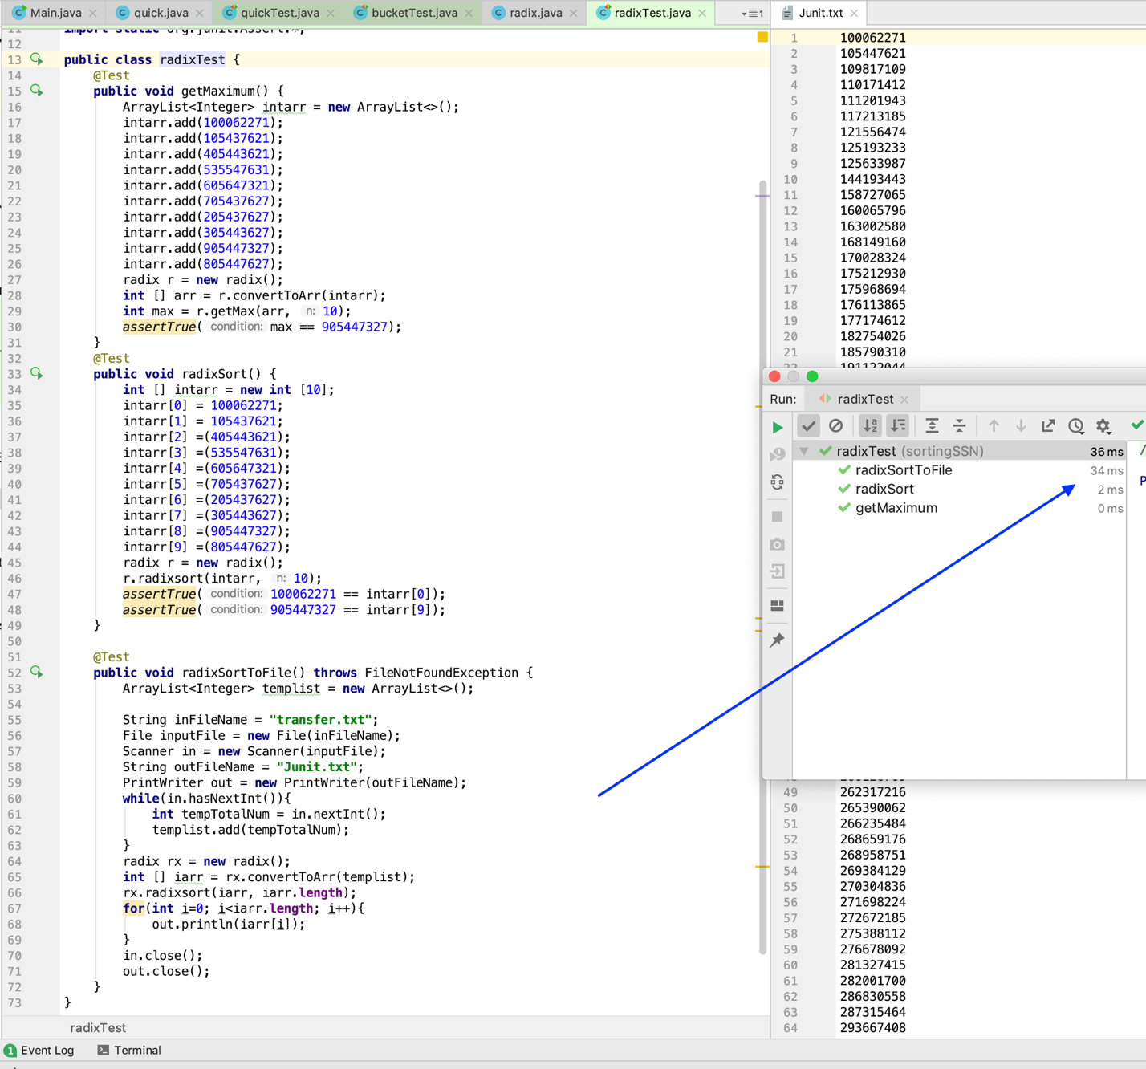

Hence , RadixSort’s running time:

* All quickTest : **36 ms**
* RadixSort: **2 ms**
* RadixSort’s total running time is $Θ$ (d(n+k))
* When pass over n d-digit numbers that take time $Θ$ (n+k)
* Total time = $Ο$ (dn + dk)
* Since d is constant and k= $Ο$ (n), takes $Ο$ (n) time
* Summary: Fast ! Stable ! Simple ! (Doesn’t sort in place)
* Running time summary:
* Even though, we only pick random 300 SSN numbers, which are not representative.
* However, to be academic research, I still analyze their comparison.
* This is the course’s goal——I learn from CS 146 Data Structure Algorithms
* Now I can summary the comparison between **QuickSort BucketSort RadixSort**:
* Since the **quickSort**’s worst case running time is (n2)
* **bucketSort**’s worst case running time is $Ο$ (n)
* **radixSort**’s worst case running time is $Ο$ (n)
* Thus, for my program, quickSort test is **80 ms**
* **bucketSort** and **radixSort** is faster than **quickSort**
* **Programming Assignment 2: Social Security Number**

is Done!

**Thank you for reading !**